STORMWATER MANAGEMENT PLAN

FOR

TOWN OF KITTERY, MAINE

MS4 General Permit Effective July 1, 2022
Initially Submitted to Maine DEP March 17, 2021
Updated July 28, 2021 to address DEP comments
Resubmitted as final September 3, 2021
Updated 6/13/2022 to reflect incorporate Permit Modification and May 18, 2022 Department Order
Updated August 2023

Table of Contents

1 INTRODUCTION 4
1.1 Overview of Regulatory Program 4
1.2 Cooperation Between Regulated Communities 4
1.3 Stormwater Management Plan 5
1.4 Water Quality and Discharges to Impaired Waters 6
1.4.1 State Water Quality Assessments 7
1.4.2 Kittery Water Quality Status 9
1.4.3 Impaired Waters Addressed in this SWMP 14
1.5 Priority Watersheds 14
1.6 Obtaining Coverage to Discharge 15
1.7 SWMP Availability 16
1.8 SWMP Modifications during the Permit Cycle 16
1.9 Annual Compliance Report and Record Keeping 17
2 MINIMUM CONTROL MEASURES 19
2.1 MCM 1 Education/Outreach Program 19
2.1.1 BMP 1.1 – Raise Awareness– General Public. 19
2.1.2 BMP 1.2 – Raise Awareness – Municipal Staff/Boards 21
2.1.3 BMP 1.3 – Behavior Change Campaign – Proper disposal of commonly littered items 22
2.1.4 BMP 1.4 – Overall Effectiveness Evaluation 27
2.2 MCM 2 Public Involvement and Participation 29
2.2.1 BMP 2.1 - Public Notice Requirement 29
2.2.2 BMP 2.2 - Host Public Events 29
2.3 MCM 3 Illicit Discharge Detection and Elimination 30
2.3.1 BMP 3.1 – Continue to Implement the Non-Stormwater Discharge Ordinance 30
2.3.2 BMP 3.2 – Maintain the Written IDDE Plan 30
2.3.3 BMP 3.3 - Maintain Storm Sewer System Infrastructure Map 31
2.3.4 BMP 3.4 – Conduct Infrastructure Inspections and Monitor Flowing Outfalls 31
2.3.5 BMP 3.5 – Conduct Investigations on suspect illicit discharges and flowing outfalls 32
2.3.6 BMP 3.6 – Significant Contributors of Pollutants 32
2.4 MCM 4 Construction Site Stormwater Runoff Control 34
2.4.1 BMP 4.1 – Update Requirements for Erosion and Sediment Control 34
2.4.2 BMP 4.2 – Site Plan Review Procedures 35
2.4.3 BMP 4.3 – Procedures for notifying construction site developers and operators 35
2.4.4 BMP 4.4 –Conduct and Document Construction Site Inspections 36
2.5 MCM 5 Post-Construction Stormwater Management in New Development/ Redevelopment 37
2.5.1 BMP 5.1 – Implement strategies to prevent or minimize water quality impacts 37
2.5.2 BMP 5.2 – Maintain Post Construction Ordinance or Similar Measure 37
2.6 MCM 6 Pollution Prevention/Good Housekeeping for Municipal Operations 39
2.6.1 BMP 6.1 – Operations at Municipally Owned Grounds and Facilities 39
2.6.2 BMP 6.2 – Training 39
2.6.3 BMP 6.3 – Continue Street Sweeping Program 39
2.6.4 BMP 6.4 – Cleaning of Catch Basins 40
2.6.5 BMP 6.5 – Maintenance and Upgrading of Storm water Conveyances and Outfalls 40
2.6.6 BMP 6.6 – Stormwater Pollution Prevention Plans (SWPPPs) 40
2.7 Impaired Waters BMPs 42
3 GENERAL REQUIREMENTS 43
3.1 Certification 43

APPENDICES
- Urbanized Area Map
- Notice of Intent and Permittee Specific DEP Order
- Summary of Public Comments Received
- Education & Outreach Tools, Levels of Effort, and Effectiveness Benchmarks
- IDDE Plan
- Construction Inspection Form

INTRODUCTION

Overview of Regulatory Program

The Town of Kittery is subject to the General Permit for the Discharge of Stormwater from Small Municipal Separate Storm Sewer Systems (MS4s) which was issued by the Maine Department of Environmental Protection (DEP) with an effective date of July 1, 2022. Because the permit is a Clean Water Act permit, it is limited to a duration of five (5) years and is due to expire on June 30, 2027. However, if the Maine DEP does not issue another Permit by June 30, 2027, the permit will be administratively continued, and the Town may need to update this Stormwater Management Plan to show what activities it will complete during the continued time period.

Communities are regulated under this program when and if they are identified as having “Urbanized Areas” in their municipal boundary. An Urbanized Area is a U.S. Census-defined term, applied to a large area (50,000 people or more) that has a high population density and/or a high percentage of impervious cover (hard scape surfaces like parking lots or buildings). Both of these criteria (high population density and high percentage of impervious cover) cause an area to be at risk for adverse surface water quality impacts from polluted stormwater discharges.

The U.S. Environmental Protection Agency (USEPA) and Maine DEP began regulating communities for their stormwater discharges using the Urbanized Area criteria in 2003. The Town of Kittery became regulated in 2003 based on the 2000 census.

Once a community becomes regulated by the MS4 General Permit, only the Urbanized Area portions of the town are regulated. As each U.S. Census is published, if the Urbanized Area changes (based on changes to the population or impervious cover), additional areas can be added to the regulated area only after a new MS4 General Permit is issued. Once an Urbanized Area is regulated by the MS4 General Permit, it cannot be removed from regulation, even if a subsequent census identifies it is no longer classified as an Urbanized Area. So, the area regulated by the MS4 General Permit can either grow larger or stay the same size, but it cannot become smaller. Appendix A shows the Urbanized Area that is regulated by the 2022 MS4 General Permit for the town, which is based on the combined 2000 and 2010 U.S. Census Urbanized Area data. The 2022 MS4 General Permit specifically does not include any areas identified by the 2020 U.S. Census.

Cooperation Between Regulated Communities
There are 30 municipalities in the State of Maine that are subject to the 2022 MS4 General Permit. There are also two transportation agencies which are subject to their own MS4 General Permit, and eight state/federal agencies that are subject to a third MS4 General Permit (which are called “nested” MS4s). The regulated MS4s (municipal, transportation and state/federal) have a good history of cooperating on a state-wide basis to complete activities required by the General Permit such as public outreach and training as a cost saving measure and to improve the quality of compliance.

When the Town of Kittery became regulated in 2003, it joined the four other regulated communities in York County to implement some elements of the permit cooperatively. The four other communities are Berwick, South Berwick, Eliot, and York. The Towns have branded their cooperative stormwater efforts with the name, “Southern Maine Stormwater Working Group” (SMSWG, pronounced SIM-see-wig).

Similarly, the Bangor area MS4s have formed the Bangor Area Stormwater Working Group (BASWG), the Lewiston-Auburn area MS4s formed the Androscoggin Valley Stormwater Working Group (AVSWG), and the Portland Area regulated MS4s formed the Interlocal Stormwater Working Group (ISWG). For some public education requirements, all of the stormwater working groups are working cooperatively as identified in this plan.

In implementing the 2022 MS4 General Permit, the Town of Kittery works with other entities statewide and through SMSWG to complete some requirements, hires a third party-consultant to implement some requirements and implements other requirements using municipal staff. This plan describes which elements will be completed individually, regionally or as a state-wide effort.

Stormwater Management Plan

Though the MS4 General Permit is a Clean Water Act Permit, it does not specify numeric effluent limitations (concentrations that a stormwater discharge must meet). Instead, the MS4 General Permit specifies narrative effluent limitations, in the form of Minimum Control Measures (MCMs).

Each of the historically issued MS4 General Permits (in 2003, 2008, 2013, and 2022) have required that the regulated MS4s develop and implement a Stormwater Management Plan (SWMP or Plan) to coincide with the effective dates of the General Permit.

This SWMP describes how the Town will implement Best Management Practices (BMPs) to meet the six MCMs, set forth in Part IV(C) of the 2022 MS4 General Permit. The six MCMs that are required to be addressed in this Plan are:

- Education/Outreach Program
- Public Involvement and Participation
- Illicit Discharge Detection and Elimination Program
- Construction Site Stormwater Runoff Control
- Post-Construction Stormwater Management in New Development and Redevelopment
- Pollution Prevention/Good Housekeeping for Municipal Operations

The 2022 MS4 General Permit requires that for each MCM, the Town must: define appropriate BMPs; designate a person(s) responsible for implementing each BMP; define a date or timeline with milestones for implementation of each BMP; and define measurable goals for each BMP.

The prior MS4 General Permits also required that the SWMP address these six MCMs, but the specific requirements related to each MCM have changed with each permit. In many instances, the BMPs in this plan expand upon or continue BMPs that were developed under prior General Permits.

In addition to addressing the six (6) Minimum Control Measures, the Town must address several impaired waters requirements. Sections 1.4 and 1.5 describe the water quality status in the Town, and what watersheds are considered to be priorities. Sections 1.6 through 1.9 describe how permit coverage is obtained, how the SWMP is modified (when needed), when public notice is required and annual reporting requirements.

The Maine DEP will review this Stormwater Management Plan and determine if the Town is controlling pollutants to the “Maximum Extent Practicable.” The term “Maximum Extent Practicable” is defined in the Clean Water Act. The term means available and feasible considering cost, existing technology, and logistics based on the overall purpose of the project. Effectively, the Town is allowed to consider these concepts as they select Best Management Practices (BMPs) to meet permit requirements, but the Maine DEP decides if the Town is meeting the “Maximum Extent Practicable” standard.

The SWMP is not an enforceable document , however, some of its elements are enforceable as identified in The Town’s Department Order contained in Appendix B. Some flexibility is built in to the SWMP to allow communities to engage in an adaptive management approach to mitigating or eliminating the discharge of pollutants to and from its regulated small MS4. This allows the Town to adjust the SWMP and BMPs throughout the Permit Cycle if needed based on evaluations of their effectiveness, changing conditions, specific local concerns, or changes in other factors. Some SWMP Modifications require DEP review and approval and public notice. Section 1.6 Obtaining Coverage to Discharge, and Section 1.8 SWMP Modifications describe the requirements associated with modifying a SWMP.

Water Quality and Discharges to Impaired Waters

The 2022 MS4 General Permit contains the following requirements for discharges to waters that are not meeting their fishable and swimmable standards (a.k.a. impaired waters):

      - If the waterbody to which a point source discharge drains is impaired and has an EPA approved total maximum daily load (TMDL), then the SWMP must propose clear, specific, and measurable actions to comply with the TMDL waste load allocation (“WLA”) and any implementation plan. The GP does not authorize a direct discharge that is inconsistent with the WLA of an approved TMDL. This requirement applies only to TMDLs that were approved by EPA as of 10/15/2020.
      - If a TMDL is approved or modified by EPA after 10/15/2020, the Maine DEP will notify the permittee if any changes are needed to the SWMP and may take other actions regarding the approved TMDL as identified in the 2022 MS4 General Permit.
      - If an MS4 has a discharge to an Urban Impaired Stream, it must develop and implement three (3) BMPs to address the water’s impairment, unless the DEP has determined the MS4 discharge is not causing or contributing to the impairment.

The Fact Sheet that was issued with the 2022 MS4 General Permit also contained a strongly worded recommendation for MS4s to consult with the Maine DEP Division of Environmental Assessment regarding impaired waters that do not have approved TMDLs. The consult would be focused on identifying the root cause of the impairment and developing a strategy to reduce the discharge of pollutants of concern if the permittee is causing or contributing to the impairment.

Section 1.4.1 describes generally how the State evaluates surface waters and describes TMDL documents and Urban Impaired Streams. Section 1.4.2 describes the status of the waters that receive discharges from the Town’s MS4. Section 1.4.3 describes how the Town is addressing any impairments which have MS4 requirements.

State Water Quality Assessments

The State of Maine is required by the Clean Water Act to identify water quality classifications for each surface water in the State, and then to assess whether each of those waters is meeting its designated classification standards. Maine has four classifications for freshwater rivers, three classes for marine and estuarine waters, and one class for lakes and ponds. Each classification identifies a use and set of water quality standards for the water. The classifications, uses, and standards are described and assigned to the various waters in the Maine Statutes (Title 38, Sections 464 through 469).

Assessments as to whether each water is achieving its designated classification are based on data that is obtained from a number of sources depending on the type of water being assessed:

- Lakes and ponds are assessed primarily through data obtained by the DEP and regional entities and lake associations. The regional and lake association data is coordinated through the Lake Stewards of Maine (Volunteer Lake Monitoring Program).

- Marine and Estuarine waters are assessed by evaluation of data obtained from the DEP, Maine Healthy Beaches, Department of Marine Resources, Marine Environment’s Gulf Watch, Gulf of Maine Council, and several other academic and non-profit organizations.

- Wetlands are assessed primarily using data obtained from the DEP Biomonitoring Program.

- Rivers and Streams are assessed using data from the DEP Biomonitoring Program, Surface Water Ambient Toxics (SWAT) Monitoring Program, the Atlantic Salmon Recovery Plan, Volunteer River Monitoring Program (VRMP) and through many other government agencies such as the Department of Inland Fisheries and Wildlife, EPA, United States Geologic Survey.

Every two years, the DEP publishes a report and list documenting the results of the assessments, and identifying which waters are meeting their designated classifications, and which are considered impaired. The report and list are called the Integrated Water Quality Report and are generally referred to by the Section of the Clean Water Act which requires them: the 305(b) report and/or the 303(d) list, respectively. There are five general status categories available for assignment to each water:

- Category 1: Attaining all designated uses and water quality standards, and no use is threatened.
- Category 2: Attains some of the designated uses; no use is threatened; and insufficient data or no data and information is available to determine if the remaining uses are attained or threatened (with presumption that all uses are attained).
- Category 3: Insufficient data and information to determine if designated uses are attained (with presumption that one or more uses may be impaired).
- Category 4: Impaired or threatened for one or more designated
  - 4A means a TMDL has already been completed
  - 4B means other pollution control measures will address impairment, so no TMDL is required to be completed
  - 4C means the impairment is not caused by a pollutant and so does not require development of a TMDL (Total Maximum Daily Load) report.
- Category 5: Waters impaired or threatened for one or more designated uses by a pollutant(s), and a TMDL report is required.

In Maine, the most current 303(d) list approved by the EPA is from the 2016 data. The Maine DEP has indicated they will issue a combined 2018/2020/2022 303(d) list sometime in 2022.

A TMDL document identifies the source(s) of the impairments and recommendations to correct the impairments. In particular, a TMDL document identifies how much of a pollutant a water body can receive and still meet its water quality classification. Typically, the units are identified as pounds per day, which is the basis for the term “Total Maximum Daily Load.” TMDLs typically include a Margin of Safety between 2 and 5% of the TMDL to account for uncertainties or lack of knowledge about the relationship between the pollutant loading and water quality.

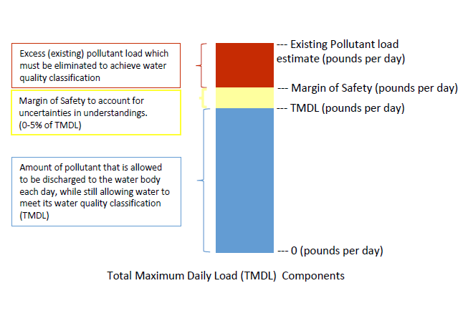
In addition to the Maine 305(b) report and 303(d) list, Maine has developed a special rule, Chapter 502, which has restrictions related to Direct Watersheds of Lakes Most at Risk from New Development and Urban Impaired Streams. This rule became effective in 1997 and has been modified several times over the years. The rule defines an Urban Impaired Stream as a stream that fails to meet its water quality standards because of effects of stormwater runoff from developed land. The rule imposes additional stormwater treatment controls on development in the watersheds of Urban Impaired Streams.

Kittery Water Quality Status

This section provides a summary of the waters in the Town’s Urbanized Area that receive point source discharges from the Town’s MS4 and each waterbody’s TMDL and impairment status.
Table 1 shows the waters where the Town has MS4 discharges and their impairment status. The Table shows the number of MS4 outfalls (in parentheses) that discharge to each waterbody as of December 2020.

The following documents were reviewed developing Table 1:

- Piscataqua River Estuary TMDL (1999)
- Statewide Bacteria TMDL (September 2009 and 2013 Addendum)
- Impervious Cover TMDL (September 2012)
- Non-Point Source TMDL (2015)
- Final 2016 Maine Integrated Water Quality Report and Appendices [a.k.a. Maine 305(b) Report and 303(d) list]; Note that the DEP has indicated they will not issue a 2018 303(d) report, rather they will be issuing a combined 2018/2020/2022 303(d) report.
- USEPA and Maine DEP approved TMDL lists
- Chapter 502 Direct Watersheds of Lakes Most at Risk from New Development and Urban Impaired Streams

Figure 1 shows the locations of the fresh waters and their status according to the 2016 303(d) list from the Maine DEP GIS files (from https://maine.maps.arcgis.com/apps/webappviewer/index.html?id=dffb3d2b85904b18978d02fc9d913b5f ).

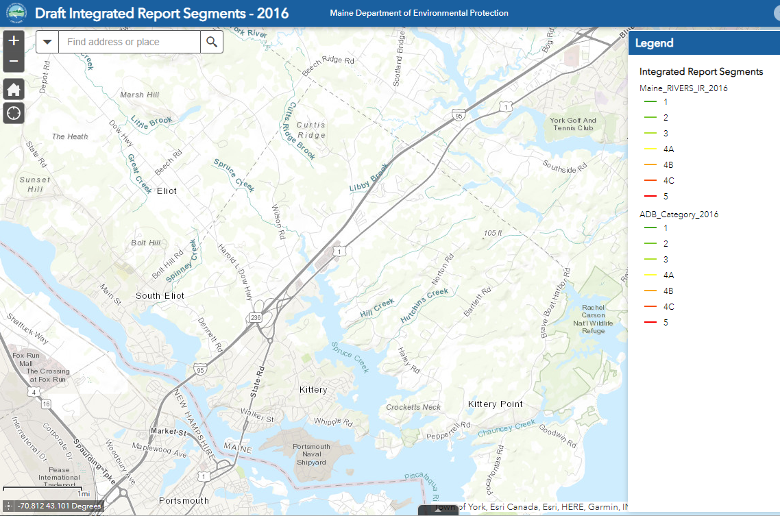
Figure 1 Kittery has no freshwater impairments

Table 1 Status of Waterbodies Receiving MS4 Discharges – Kittery Maine
Water bodies with MS4 discharges (# outfalls) | Maine DEP classification and numeric designation | DMR Area | Completed TMDLs | Urban Impaired Streams (Chapter 502) | Non-TMDL listing in 2016 303(d) list | Watershed Management Plan / Other Water Quality Document
Piscataqua River Estuary  (8 MS4 outfalls) | 812-2 SB/SC | WA  (Was 1) | Piscataqua River Estuary (1999) | None | Cat. 5-B-1 Bacteria Only  2017-2020 Shellfishing Prohibited Area  And 4A Needs TMDL for Marine Life Use Support (Eelgrass) | None
Portsmouth Harbor (Spruce Creek, Chauncey Creek, Atlantic Ocean, and associated tributaries 88 MS4 outfalls) | 812-3 SB | WA  (Was 2A-1) | None | None | Cat. 5-B-1 Bacteria Only  2017-2020 Shellfishing Prohibited Area  And 4A Needs TMDL for Marine Life Use Support (Eelgrass) | Spruce Creek Watershed Management Plan
Atlantic Ocean (from Sister’s Point North to York)  (No MS4 outfalls) | 826 SB | WB  (Was 3) | None | None | Not applicable | There are no Kittery MS4 discharges to DMR 3
Legion Pond  (3 MS4 outfalls) | None | NA | None | None | None | None

Figures 2a, 2b, and 2c show the status of marine waters according to the Department of Marine Resources as of 3/1/2021. (from https://www.maine.gov/dmr/shellfish-sanitation-management/closures/index.html). Because DMR updated their designations and naming structure on 3/1/2021, the Figures reflect the new designations and naming structure and Table 1 shows both the new designation and the old DMR designation that was in effect when the 2022 MS4 General Permit was finalized on 10/15/2020. These areas are also listed under their old designations on the 2016 Maine DEP 303(d) list for elevated bacteria concentrations. The Maine DEP does not otherwise provide graphic representation of the locations of the marine/estuarine waters that are listed as impaired in the 2016 303(d) list.

Figure 2a – DMR Area WA Figure 2b – DMR Area WB - Overview
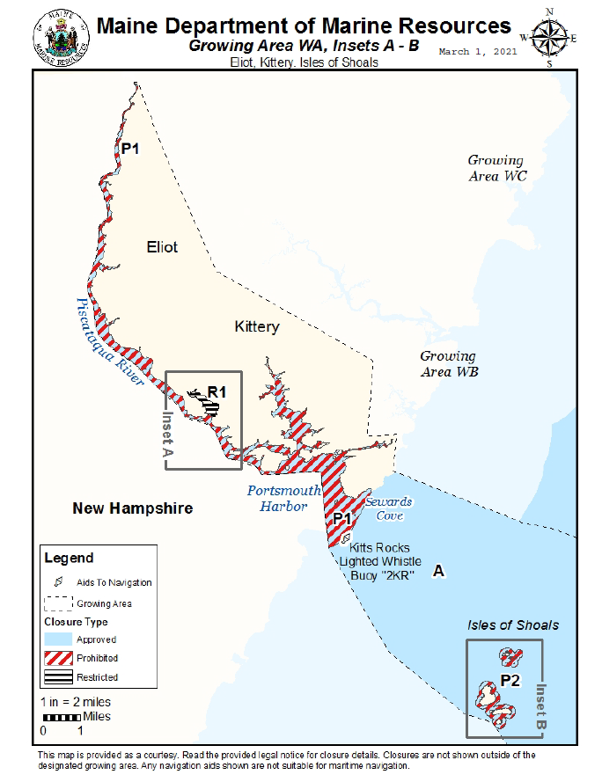
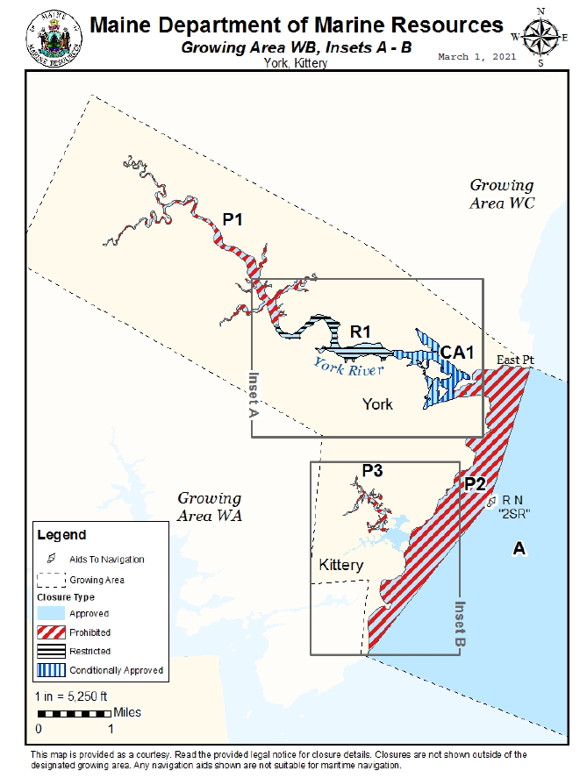

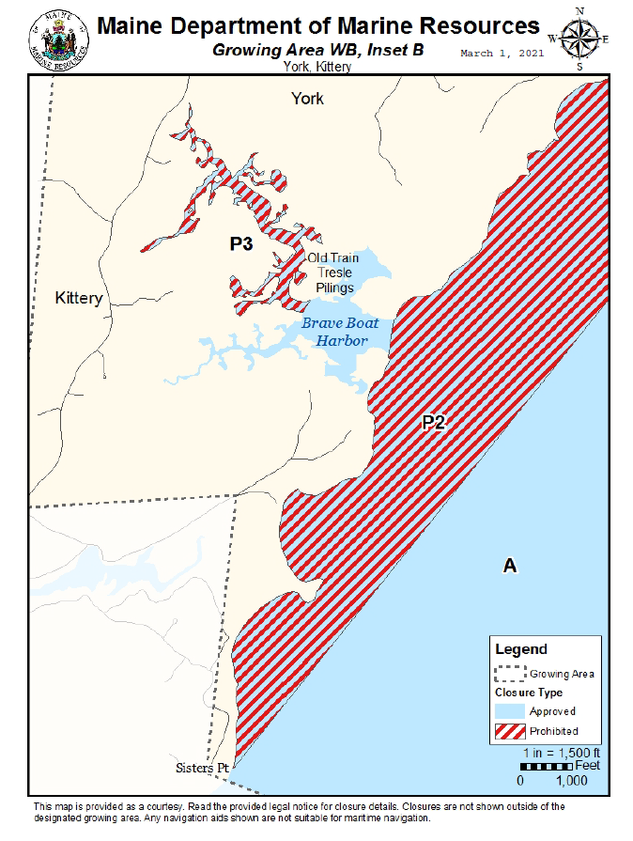
Figure 2c – DMR Area WB – Inset B

Table 1 shows the Town does not have any Urban Impaired Streams and has only a few outfalls that discharge to the Piscataqua River Estuary, which has a 1999 TMDL for Dissolved Oxygen.

Table 1 shows several of the Town’s estuarine/marine waters are listed as impaired for shellfishing due to bacteria only, but that no TMDL is applicable to these waters. These waters used to be listed in the 2009 Bacteria TMDL but were re-categorized in 2016. The recategorization is temporary until the Maine DEP can re-issue the Bacteria TMDL.

Impaired Waters Addressed in this SWMP

Because the Town does not discharge to any Urban Impaired Streams no BMPs or action need to be implemented regarding these waters.

The 1999 Piscataqua River Estuary TMDL for Dissolved Oxygen did not identify any WLA or implementation plan regarding stormwater discharges, so no BMPs or actions need to be implemented for that water.

As stated in the 2022 MS4 General Permit Fact Sheet, the Town consulted with the Maine DEP Division of Environmental Assessment to understand if any action needed to be taken to address discharges to impaired waters without TMDLs through the MS4 Permit.

The only waters that fall in this category are waters that are marine/saline waters that are impaired for shellfishing due to bacteria only (DMR areas 1 and 2-A1), and subsegments of those waters that are also impaired for not supporting marine habitat (eelgrass).

The consultation with Maine DEP revealed:
    - The DEP has not fully specified the root cause of the impairments, but suspects that stormwater is a contributing factor
    - That implementation of the IDDE elements of the MS4 General Permit (conducting outfall inspections, sampling outfalls during dry weather flow, and completing IDDE investigations to eliminate any bacterial sources), are sufficient to address the impairment until such time as the Bacteria TMDL document can be updated, and any additional TMDL can be created.

Priority Watersheds

Previous MS4 General Permits required that regulated MS4s identify a Priority Watershed and apply BMPs to that Watershed. The 2022 MS4 General Permit does not contain any specific requirements related to Priority Watersheds. However, it does require that an MS4 have a procedure in place to prioritize watersheds when addressing illicit discharges. The Town of Kittery uses this prioritization to identify where illicit discharge inspections are conducted first.

The Town may also use the prioritization for illicit discharge investigations in the event there were insufficient resources to address all potential illicit discharges simultaneously. The IDDE Plan describes in more detail how the prioritization is applied.

The Maine DEP maintains a list of waters that are vulnerable to non-point source pollution, which is then available to receive grant funding under Sections 308(b) and 319 of the Clean Water Act as long as the funding is not used to satisfy the conditions of a Clean Water Act Permit (such as the 2022 MS4 General Permit). The list includes the MS4’s “Priority Watershed”.

MS4s should keep in mind that they may not use 319 grant funding to implement any BMPs required by the MS4 General Permit.
Watersheds, subwatersheds and drainage areas are described using a national naming and numbering system. Watersheds are described using a 10-digit Hydrologic Unit Code (HUC). Watersheds are divided into smaller divisions called subwatersheds and are numbered by retaining the 10-digit HUC from the watershed and adding two additional digits to form a resultant 12-digit HUC. National HUC data sets end with the 12-digit HUC subwatersheds. Municipalities and/or states typically subdivide the subwatersheds into smaller drainage areas, again retaining the 12-digit HUC of the parent subwatershed and adding two more digits.
Approximately 80% of the Urbanized Area is contained within the watershed called, Hampton River Frontal Atlantic Ocean (HUC 0106000310). The Hampton River Frontal Atlantic Ocean Watershed is made up of several subwatersheds, but the Town of Kittery Urbanized Area is entirely contained in the Portsmouth Harbor Subwatershed (HUC 0106000310-01), which is effectively the Piscataqua River estuary and the Portsmouth Harbor area (DMR areas 1 and 2).

The town’s priority watershed is the Hampton River Frontal Atlantic Ocean Watershed (and the Portsmouth Harbor subwatershed) because it includes the Spruce Creek Watershed. Local residents created a Watershed Management Plan for Spruce Creek in 2014 and has been implementing the recommendations of the Plan to help repair the water’s impairments. Most of this work has been completed using the CWA Section 319 funding.

The remaining portions of the Towns Urbanized Area are contained in the watershed called, Frontal Drainages of Southern York County (HUC 0106000311), which is in the northern and eastern portions of Town.

Obtaining Coverage to Discharge

As required, a Notice of Intent (NOI) to comply with the 2022 MS4 General Permit was submitted to the Maine DEP with this SWMP. A copy of the Town’s NOI is provided in Appendix B.

30-day Public Notice was provided by both the Maine DEP and the Town to allow the public to comment on the SWMP. A copy of the Public Notice provided by the Town is contained in Appendix B.

Following review of the SWMP and NOI, and receipt of any public comments, the Maine DEP issued a permittee specific DEP Order, establishing terms and conditions that are enforceable in addition to the language in the 2022 MS4 General Permit which is also enforceable.

The permittee specific DEP Order was also subject to a 30-day public comment period by DEP. This Town’s DEP Order was issued for public comment in November 2021, was modified by DEP based on comments received and was re-issued for public comment in March 2022.

After the public comment period ended, and the DEP finalized the DEP Order based on any comments received, the Town had 60 days to update the SWMP to reflect any new or changed requirements based on the DEP Order and any comments. This SWMP has been updated to reflect any public comments. Maine DEP did request that this SWMP be resubmitted to them.

Appendix B contains the Final permittee specific DEP Order and shows the comments received and the DEP responses to comments. Appendix C contains the comments received from the public along with any notes on how the comments were addressed in the SWMP.

Additional Annual updates are available on the Town’s website.

SWMP Availability

The SWMP must be made available to the public by publishing on the Town Website. A copy must also be made available to the public at the municipal offices. The Town of Kittery makes the SWMP available at the Public Works office, which is adjacent to Town Hall.

If any of the following entities request a copy, one must be made immediately available to them:
  - USEPA or Maine DEP,
  - Any interconnected or adjacent MS4,
  - Any owner or operator of a water supply company where the MS4 discharges to a water supply watershed, or
  - Members of the public.

SWMP Modifications during the Permit Cycle

During the permit term (2022 to 2027), the SWMP must be kept current. As required by the 2022 MS4 General Permit, the Town will amend the SWMP if the Maine DEP or the Town determine that:

  - The actions required by the BMPs fail to control pollutants to the meet the terms and conditions of the 2022 MS4 General Permit and the permittee specific DEP Order;
  - The BMPs do not prevent the potential for a significant contribution of pollutants to waters of the State other than groundwater; or
  - New information results in a shift in the SWMP’s priorities.

If the changes are initiated by the Maine DEP, it will notify the Town, and the Town must respond in writing within 30 days of the notice explaining how it will modify the SWMP. The Town must then modify the SWMP within 90 calendar days of the Town’s written response, or within 120 calendar days of the DEP notice (whichever is less). Any such modification must be submitted to the DEP for final review.

If the changes are initiated by the Town, the following processes apply (depending on the nature of the change as identified below):

- To modify any schedule identified in the permittee specific DEP Order, the permittee must file an application on a DEP form with the Department that includes a justification to formally modify the original permittee-specific DEP Order.

- The permittee must allow the public the opportunity to comment on changes made to the SWMP a minimum of once per year.

- For BMPs in the SWMP that are not required to comply with the General Permit or the permittee specific DEP Order, the BMPs and/or implementation schedule may be amended as appropriate without the need for public comment. Changes must be submitted to the Department in the Annual Report following the permit year the change(s) were made.

- .

Annual Compliance Report and Record Keeping

By September 15 of each year, the Town will electronically submit an Annual Compliance Report for the Maine DEP's review using a standardized form provided by the Maine DEP or an alternate form reviewed and approved by Maine DEP. The Annual Compliance Report must be sent via email to the Municipal Stormwater Coordinator. As of April 2022, the Maine DEP Municipal Stormwater Coordinator is:

Holliday.Keen@maine.gov Municipal/Industrial Stormwater Coordinator
Department of Environmental Protection
17 State House Station
Augusta, Maine 04333-0017

The Annual Compliance Report must include the following:

- The status of compliance with the terms and conditions of the 2022 MS4 General Permit and the Town’s permittee specific DEP Order, based on the implementation of the Town’s Plan for each permit year, an assessment of the effectiveness of the components of its stormwater management program, an assessment of the appropriateness of identified BMPs, progress towards achieving identified measurable goals for each of the MCMs and progress toward achieving the goal of reducing the discharge of pollutants to the MEP
- A summary of information collected and analyzed, including monitoring data, if any, during the reporting period.
- A summary of the stormwater activities the Town intends to undertake pursuant to its Plan to comply with the terms and conditions of the 2022 MS4 General Permit and the Town’s permittee specific DEP Order during the next reporting cycle.
- A change in any identified BMPs or measurable goals that apply to the Plan.
- A description of the activities, progress, and accomplishments for each of the MCMs #1 through #6 including such items as the status of education and outreach efforts, public involvement activities, stormwater mapping efforts, the number of visual dry weather inspections performed, the number of inaccessible and new outfalls, dry weather flow sampling events and laboratory results, detected illicit discharges, detected illicit connections, illicit discharges that were eliminated, construction site inspections, number and nature of enforcement actions, post construction BMP status and inspections, the number of functioning post construction BMPs, the number of post construction sites requiring maintenance or remedial action, the status of the permittee’s good housekeeping/pollution prevention program including the percentage of catch basins cleaned, those catch basins cleaned multiple times and the number of catch basins that could not be evaluated for structural condition in a safe manner. Where applicable, the MS4 must quantify steps/measures/activities taken to comply with the 2022 MS4 General Permit and its Plan including reporting on the types of trainings presented, the number of municipal and contract staff that received training, the length of the training and training content delivered as well as any revisions to the SWPPP procedures and/or changes in municipal operations.

The Maine DEP will review the annual reports and provide comments to the MS4s. Changes to the report based on the Maine DEP's review comment(s) must be submitted to the Department within 60 days of the receipt of the comment(s).

The regulated MS4s must keep records required by the 2022 MS4 General Permit and permittee specific DEP Order for at least three (3) years following its expiration or longer if requested by the Maine DEP Commissioner. The regulated MS4s must make records, including this Plan, available to the public at reasonable times during regular business hours.

MINIMUM CONTROL MEASURES

MCM 1 Education/Outreach Program

The 2022 MS4 General Permit requires the Towns develop two Education/Outreach Campaigns to address stormwater issues of significance:
            - An Outreach to Raise Awareness Campaign targeted at two audiences: one target audience must be the general public, and the second audience may be selected from: municipal, commercial, development/construction or institutions. A minimum of three tools must be directed at each audience each year.
            - An Outreach to Change Behavior Campaign promoting one behavior change targeted at two audiences. A minimum of three (3) outreach tools must be directed at each audience each year to promote and reinforce desirable behaviors (designed to reduce stormwater pollution).

In 2018, ISWG executed a statewide survey around public awareness of stormwater issues and behaviors that impact stormwater. The survey results were summarized in the SMSWG Permit Year 5 (2017-2018) annual report. The SMSWG communities discussed the results of the statewide survey, reviewed water quality status related to stormwater issues, considered their first-hand knowledge of their communities, and the needs for public education around stormwater at four of their regional meetings (9/26/2018, 5/29/2019, 7/31/2019, and 9/30/2020) before deciding what issues of significance to address, and what tools and messages might be effective. Each of the BMPs provides a brief introductory section describing the rationale for the selection of the BMP based on the SMSWG communities’ understanding of their areas.

The SMSWG towns will cooperate regionally and with the ISWG to complete the requirements of the Education/ Outreach Program as identified in the Responsible Party section of each BMP. The Towns will fulfill the requirements of this MCM by implementing the following BMPs.

BMP 1.1 – Raise Awareness– General Public.

Responsible Party – Public Works Inspector (with implementation assistance from a cooperative ISWG/SMSWG effort)

The 2022 MS4 General Permit requires the permittee to raise awareness of the public as well as one of the following groups: municipal, commercial, development/construction, or institutions. Measurable Goal 1.1a describes the actions the Town will take to raise awareness of the public, and Measurable Goal 1.1b describes the action the Town will take to raise awareness of municipal staff and board members. Rationale for the selection of the target audiences is provided here also.

Background for Measurable Goal 1.1a Public Audience: The Think Blue Maine campaign began in 2003 as a statewide effort to raise awareness of common stormwater pollutants and ways to prevent those pollutants. The Think Blue Maine campaign has been historically successful in increasing awareness of stormwater issues. ISWG, AVSWG, and SMSWG coordinate their Think Blue Maine messaging and education efforts to provide consistent messaging in Southern Maine. In addition, the Massachusetts and New Hampshire small MS4s are using similar Think Blue campaigns, so there is some regionally consistent messaging in circulation.

In 2018, the ISWG executed a statewide survey around public awareness of stormwater issues and behaviors that impact stormwater. Only 15 of the survey respondents in the SMSWG region were ages 25 to 34, but all of them stated it was “very important to have clean water in the lakes and streams in [their] community”, and 12 of them believe that stormwater runoff has a major impact or somewhat impacts water quality. As was true of the ISWG demographic in this age group, 47% of SMSWG respondents ages 25 to 34 were able to correctly describe what happens to stormwater at their residence. Because this age group has not been targeted before and has potential to impact stormwater for many years in the future, the ISWG, AVSWG, and SMSWG communities will cooperatively use the Think Blue Maine campaign to raise their awareness of stormwater issues. This will increase their likelihood to implement beneficial behavior change in the future.

Measurable Goal 1.1a – The Town will implement the following program which is designed to raise 15% of the target audience’s awareness of what happens to stormwater at their residence or place of work. According to the 2019 US Census Bureau, the SMSWG region’s population for ages 25 to 34 is approximately 4,100 people, 15% of the target audience is approximately 600 people.
Target Audience: People 25 to 34 in the SMSWG region
Overarching Message: “Water that lands on our roads, roofs, and other hard surfaces picks up pollutants and carries them to our local waterbodies without being treated.”
This message will be presented with variations based on target audience interests and outreach tools used.
Outreach Tools: A minimum of three outreach tools will be selected from Appendix D Table 1 each year. Each tool will be assessed and customized based on the target audience’s receptiveness to the method. Any tool used in a given year will be tailored to the message of the relevant target audience subset based on common characteristics and/or demographics.
Evaluation: Effectiveness will be evaluated annually by tracking process indicators for each tool implemented that year and by tracking impact indicators where available (see Appendix D Table 1).
Implementation schedule: A minimum of three of the tools from Appendix D Table 1 will be implemented each year for the duration of the permit.
Adaptive Management: Tools and messaging will be reviewed and evaluated on an annual basis at a minimum for the MS4 Annual Report. To address emerging issues, opportunistic tools and outreach may also be implemented. Seasonal messaging and tool adjustments will be used when applicable. Annual Report findings will be incorporated into ISWG meeting discussions as well as annual workplans and budgets and reported out to SMSWG for inclusion in the SMSWG Town’s Annual Reports.

BMP 1.2 – Raise Awareness – Municipal Staff/Boards

Responsible Party – Public Works Inspector

Measurable Goal 1.2a – During the 2013-2022 MS4 Permit Cycle, the Town implemented a permit awareness plan targeting municipal boards and staff. The Town identified in its final assessment (submitted to Maine DEP in PY5) that because of Board and staff turnover, the awareness program is very important. The final assessment for the prior permit cycle is being used as the baseline assessment for this permit cycle.

Target Audience: The Town will continue to raise awareness of the MS4 Program targeting one Board per year (either the Planning Board or the Select Board/Town Council) and any new Town Manager, Planner, Public Works Commissioner or Code Enforcement Officer.
Message: The Staff and/or Board’s Role is important in implementing the MS4 Program and protecting waters from stormwater pollution.

Schedule: The following tools will be used each year to implement this BMP.

Tool 1 Fact Sheet: The Responsible Party for this MCM will review a Town-specific MS4 Fact Sheet and update it if needed. The Fact Sheet will be maintained on Town’s stormwater web page and used in Tools 2 and/or 3 if deemed appropriate by the Responsible Party.
Tool 2 Meeting or Materials: The Responsible Party for this MCM will either attend or provide written materials to a Planning Board or Town Council/Select Board for their consideration at a meeting. Topics that may be covered include: (a) the MS4 Program in general, or (b) a specific element of the MS4 program pertinent to the Board, or (c) an invitation to a public participation event (BMP 2.2).
Tool 3 New Staff: Whenever a new Town Manager, Planner, Public Works Commissioner or Code Enforcement Officer is hired the Responsible Party for this MCM will meet with or provide written materials to the new staff member to review their responsibilities related to the 2022 MS4 General Permit.

Effectiveness Benchmark (e.g., the target for awareness): Effectiveness will be evaluated annually by tracking the process indicators for each tool that is implemented that year, and by tracking impact indicators where available. The Measurable Goal will be considered effective if the following occur:
- Tool 1: The Fact sheet is reviewed and updated if needed
- Tool 2: If the engagement by the board members during a presentation (or discussion of written materials) indicates they understand their role is important in implementing the MS4 Program, or by the number of board members that attend the BMP 2.2 Public Participation event (if invited)
- Tool 3: If any new staff are hired: the meeting occurs, or the written materials are provided, and the new staff indicate they understand their MS4 responsibilities.

BMP 1.3 – Behavior Change Campaign – Proper disposal of commonly littered items

Responsible Party – Public Works Inspector

Background for BMP 1.3:
The SMSWG communities selected proper disposal of litter as their primary behavior change goal with a focus on proper disposal of cigarette butts and pet waste for the following reasons:

      - Litter is a nationally recognized issue related to stormwater – litter carries pollutants with it and many forms of litter are harmful to aquatic life. Cigarette butts contain carcinogenic substances, and non-biodegradable elements that can be ingested by aquatic life. Pet waste carries high concentrations of nutrients including bacteria and nitrogen. And purchased food wrappers and containers are typically plastic or paper which do not biodegrade and contains some excess or residual food item which contains nutrients.

      - Supported by Maine Statewide Stormwater Survey - The Maine Statewide Stormwater Survey conducted in Permit Year 5 of the previous cycle identified that 80% of survey respondents are aware that pet waste trash is a common stormwater pollutant, and 92% are aware that trash is a common stormwater pollutant, and they believe that picking these items up and putting them in the trash can reduce water pollution. Their awareness of these issues makes behavior changes more likely to be implemented (people must be aware of a problem before they are likely to take steps to help correct the problem).

      - National Study Data for cigarette butts - Keep America Beautiful prepared a detailed study called Littering in America (2009) with a companion document, National Visible Litter Survey and Cost Study (2009). This was the first national study of littering since 1969, and while overall littering had decreased significantly, there is still a lot of littering going on. The SMSWG communities reviewed the studies to identify sources of pollutants and target audiences that could benefit from public education activities. In particular, the following findings lead the SMSWG communities to identify the target audiences and messaging shown in Measurable Goals 1.3a and 1.3b:
- Cigarette butts are the number one littered item on roadways and in storm drains and the number one or two littered items in non-roadway areas (such as recreational areas, retail areas, construction sites, and transition points like building or park entrances).
- 81% of littering behavior occurs with notable intent (primarily cigarette butts and confectionary/candy wrappers), and an individual’s awareness attitudes, and feelings of personal responsibility are most of the driving factors that lead people to litter (85%) and these items should be addressed through targeted messaging:
  - Most intentional litterers believe someone else will pick it up or believe someone else should pick it up as part of their job description, and do not understand the cost of their littering behavior.
  - Most intentional litterers also believe that cigarette buts are “natural” or “organic” and will decompose naturally. But the filters contain cellulose acetate, a form of plastic that does not biodegrade and can persist in the environment, adversely affecting marine and freshwater creatures when it reaches waterways.

- Even though the individual awareness and attitudes are 85% of the driving factors for littering, the following contextual issues also contribute to littering, and so any good reduction program should address these also:
  - the availability of receptacles is an important factor in littering behavior (where trash receptacles are more than 10 feet away from a transition point such as a building entrance, more littering is conducted).
  - The presence of existing litter makes individuals more likely to litter.

- Age is a significant factor in intentional littering (individuals age 30 and below are more likely to litter than older people).
- The number of adult smokers in Maine according to the CDC Map of Cigarette Use Among Adults | STATE System | CDC is 15.4 to 18.6%. The CDC reports that 7-9% of high school students smoke in Maine.
- Recommendations from the study included making proper disposable convenient and accessible, ensuring consistent and ongoing clean-up efforts, and using messaging that highlights social disapproval for littering and a preference for clean, litter-free communities, focusing on individual responsibility.

      - National Study on Pet Waste Issues - The Journal of Applied Psychology published a study (July 2006 issue, study by Paul Webley and Claire Siviter) where dog owners were observed along 8 popular dog walking paths in Lancashire, U.K. This study confirmed that although 60% of dog owners pick up after their dog, the 40% of dog owners who do not pick up after their dog do so because they believe that the feces are natural and biodegradable, and they do not understand the health and environmental impacts of leaving the feces on the ground. The study identified that the dog owners who did not pick up after themselves were more likely to believe that laws and regulations requiring them to pick up the waste were not legitimate. The study concluded that positive messaging that most dog owners pick up after their dogs would likely be effective in changing the behavior of the minority. Additionally, more current studies confirm that the belief that the feces are natural, and biodegradable is a significant contributor to individuals’ justifications for not picking it up. Other barriers include belief that someone else should pick it up (it’s their job, that is what I pay taxes for), or it’s like fertilizer (good for the ground), or there is no access to bags or disposal sites.

      - Pet Waste and Trash are local issues, and existing removal efforts need support - Local efforts are in place to remove litter from beaches, ditches, roadsides, and parks in the communities. These efforts occur annually and provide a good anecdotal and baseline information about the cigarette butt and pet waste problems in each community, but more work needs to be done to educate individuals in these communities. The following is a brief summary of the local issues identified:

- The Kittery, York, Eliot, and South Berwick Conservations Commissions were contacted in 2020 and confirmed that littering was an issue in each community, though not specifically, cigarette butts and pet waste, they identified local fast-food waste (South Berwick) and roadside beverage containers (Eliot).
- Kittery, York, Eliot, and South Berwick Conservations Commissions organize local clean up events: roadside cleanups (South Berwick) and Beach and park areas (Eliot, Kittery, and York). (Berwick does not have a conservation commission).
- The Conservation Commissions expressed an interest in partnering on public education and clean-up efforts.
- The Litterati Ap was used as a pilot to assess its usefulness and create some baseline data regarding cigarette butt issues. Though not a statistically significant data set, the following supports the national studies that show that cigarette butt littering is widespread. In addition, the Litterati Ap was easy to use and has an administrator’s interface that provides summary data which will facilitate documentation of litter found and removed from the environment:
  - Berwick Town Hall: In the summer of 2020, 59 pieces of litter were collected in a walk around Sullivan Square – 20 of the pieces collected were cigarette butts.
  - Berwick Town-wide: In April 2021, the Town of Berwick promoted an earth day cleanup week in which 3,869 pieces of trash were collected. Of the 686 pieces of litter that were categorized, 25% were smoking related (cigarette butts, cigar butts, or packaging).
  - Two areas of Eliot were walked in the summer of 2020 (~ 200-foot segments of two rural roads) and the areas at stop signs were identified with multiple cigarette butts.
  - For Kittery in the summer of 2020 the busy intersection of State Street and Walker Street was walked and 36 of 44 items observed were cigarette butts or packages.
  - In York in the summer of 2020, a walk along a 100-foot segment of York Street in front of Town hall identified 7 cigarette butts of 13 litter items.
- The Litterati Ap can also be used to collect and code data on pet waste and will be used to collect baseline data during Permit Year 9 of the 2013-2022 permit cycle. The following baseline data has already been collected:
  - For Kittery, in the summer of 2021, Rogers Park was walked using the Litterati Ap to document waste. Of the 61 pieces of litter collected, 4 were unbagged dog waste, 2 were bagged dog waste, one was an unused dog waste bag.

- During Permit Year 1, feedback from public use of the Litterati Ap identified an alternative litter tracking ap should be used. The spatial data previously obtained has been saved and an alternative spatial Ap will be used use.

Measurable Goal 1.3a –The Town will work toward changing the behavior of residents who smoke and intentionally litter cigarette butts using the messaging, and tools described below:

Overarching Messages: Cigarette butts do not decompose and are harmful to the environment and aquatic organisms. Cigarette butts should be disposed of as regular waste.

The specific messages used for each tool will address various barriers to understanding these concepts depending on any specific subsegment of the audience being targeted.

Schedule: Three of the following tools will be used each year to implement this BMP in each community. More than three tools are included in this Plan to allow for flexibility in implementation from year to year.

Optional Tool 1 Stencil 40 storm drains in beach, park, neighborhood, and/or downtown areas.
Optional Tool 2 The SMSWG regional collaborative will create, and issue four seasonal social media or website posts related to cigarette litter.
Optional Tool 3 The Town will install and ensure maintenance is conducted on at least two Sidewalk Buttlers, or similar products with messaging at targeted areas, and will create and issue informational flyers, posters or stickers. Town may work with a retail facility and ask that they conduct maintenance on the Buttler.
Optional Tool 4 Offer 40 free automobile cigarette cup holders at Town Hall if recipients provide an email address for info on follow up to their use/effectiveness (because cars do not have ash trays).
Optional Tool 5 Create and use 4 truck magnets or bumper stickers with message for public works vehicles or other town vehicles or shrink wrap one town vehicle with message.
Optional Tool 6 Offer one local or regional workshop and training for use of litter tracking Aps to the Conservation Commission or other local interested group. The workshop may be conducted in cooperation with other SMSWG communities as long as two workshops are offered to the region each year this tool is used.

Effectiveness Benchmarks Each year the following process indicators will be documented for whichever corresponding tool was used (note that not all tools will be used each year):
1. The number of basins stenciled,
2. The number of social media posts made, how many people they reached, and how many engagements there were on each post,
3. Number of Sidewalk Buttlers placed and maintained, and total quantity of cigarette butts collected in Sidewalk Buttlers that are maintained by municipalities, or information on use from retailers on use (which may be qualitative),
4. Number of cigarette cup holders distributed
5. Number of magnets or bumper stickers applied and used.
6. Number of workshops held and number of attendees.

In addition to the process indicators, the Town will use the location and quantity of cigarette butts identified during the following activities to guide messaging, tool selection and use, and to assess impact:
- during catch basin cleaning
- during outfall inspections
- from the litter tracking Ap that is in use
- from MCM2 cleanup data

Based on the literature reviewed and local data collected using the Litterati Ap, it is estimated as a baseline that cigarette butts constitute approximately 25-50% of the littered items in transitional and high traffic areas. The following are examples of conditions under which tools will be deemed effective:
- if the total quantity of cigarette butts collected each year in the Sidewalk Buttlers increases
- if the total quantity of cigarette butts observed in and around stenciled catch basins or catch basins that are near any Sidewalk Buttlers decreases
- if the total quantity of cigarette butts collected during roadside and beach cleanups decreases from prior years, or decreases relative to other litter sources (e.g., if cigarette butts begin constituting a smaller relative portion of littered items).

Measurable Goal 1.3b – The Town will work toward changing the behavior of pet owners who walk their dogs in public spaces using the messaging and tools below.

Overarching Message: Collect your pet waste and dispose of it properly (solid waste). Pet waste does not decompose quickly, it is not a natural fertilizer, and can adversely impact water quality.

Schedule: Three of the following tools will be used each year to implement this BMP. More than three tools are included in this Plan to allow for flexibility in implementation.

Optional Tool 1 Stencil 20 storm drains in beach, park, neighborhood, and/or downtown areas.
Optional Tool 2 The SMSWG regional collaborative will create, and issue four seasonal social media or website posts related to pet waste
Optional Tool 3 Install/Maintain signs at a minimum of one area identified as having pet waste issues.
Optional Tool 4 Include a handout/postcard provided when dog license is issued, or at shelters or doggie day cares or vets… (reminders)
Optional Tool 5 Create and use 3 truck magnets or bumper stickers with message for public works vehicles or other town vehicles or shrink wrap one town vehicle with message.
Optional Tool 6: Offer one local or regional workshop and training for use of litter tracking Aps to the Conservation Commission or other local interested group. The workshop may be conducted in cooperation with other SMSWG communities as long as two workshops are offered to the region each year this tool is used.
Optional Tool 7 Install/Maintain pet waste bag and disposal posts at two high traffic locations for dog walkers.

Effectiveness Benchmarks: Each year the following process indicators will be documented for whichever corresponding tool was used (note that not all tools will be used each year):
1. The number of basins stenciled,
2. The number of social media posts made, how many people they reached, and how many engagements there were on each post.
3. Number of signs applied
4. Number of handouts provided with pet licenses
5. Number of magnets or bumper stickers applied and used.
6. Number of workshops provided and number of attendees at each workshop.
7. Number of pet waste bag and disposal posts installed and maintained.

In addition to the process indicators, the Town will use the location and quantity of pet waste and/or pet waste baggies identified during the following activities to guide messaging, tool selection and use, and to assess impact:
- during catch basin cleaning
- during outfall inspections
- from the litter tracking Ap in use
- from MCM2 cleanup data

Based on the literature review and local data collected it is estimated that pet waste is prevalent in most public spaces where dogs are walked, though a specific metric identifying the baseline quantity of pet waste present is not currently available. Each of the Towns used the Litterati Ap to collect baseline data before the 2022 MS4 General Permit becomes effective by assessing pet waste in one or two popular dog walking areas with reports of or suspected pet waste issues.

Once the baseline is established (to be reported in the Permit Year 9 Annual Report), the following are examples of conditions under which tools will be deemed effective:
- if the total quantity of pet waste observed in and around stenciled catch basins or catch basins that are near any posted signs or pet waste bag and disposal posts decreases
- if the total quantity of pet waste collected during roadside and beach cleanups decreases from the baseline.

BMP 1.4 – Overall Effectiveness Evaluation
Responsible Party – Public Works Inspector

Measurable Goal 1.4a – In addition to the annual effectiveness evaluations, in Permit Year 5 of the 2022 MS4 General Permit, the Town will work with the other SMSWG communities to conduct an evaluation of the overall effectiveness of the Awareness and Behavior Change BMPs (BMPs 1.1 through 1.3) to assess progress toward each benchmark listed. The evaluation will be a review of trends in the annually reported benchmark values for the Behavior Change and Awareness BMPs as well as documentation overall of changes made each year. The evaluation will identify recommendations for future awareness and behavior change target audiences, messages, tools, and benchmarks.

MCM 2 Public Involvement and Participation

The SMSWG Towns will cooperate on Public Involvement and Participation activities on a regional basis, as described in this section of the plan.

BMP 2.1 - Public Notice Requirement
Responsible Party: Public Works Inspector

Measurable Goal 2.1a – The Town will follow state and local Public Notice requirements for its Stormwater Management Plan and Notice of Intent (NOI) to comply with the Permit. Copies of the NOI and SWMP will be made available on the Towns’ web site. If changes are made to the SWMP, the website posting will include a notice that comments can be provided to the Responsible Party to this BMP.

BMP 2.2 - Host Public Events
Responsible Party: Public Works Inspector

Measurable Goal 2.2a – The Town will either individually or regionally host or participate in an annual roadside, stream, park, or beach clean up to emphasize the importance of the behavior change BMPs 1.3 (Proper Cigarette Butt Disposal) and 1.4 (Proper Pet Waste Disposal). The event will be advertised:
  - On the Town’s website, and
  - On the SMSWG or Town Facebook page, and
  - In a local daily or weekly newspaper, or
  - One other method to be identified by the Responsible Party which replaces one of the three identified above.

The annual report will include a description of the event and the estimated attendance/participation.

MCM 3 Illicit Discharge Detection and Elimination

The Town will continue to implement its Illicit Discharge Detection and Elimination (IDDE) program, which includes:

- A Watershed-based map of the stormwater infrastructure,
- A written IDDE Plan which describes:
  - Inspections of the infrastructure during dry weather (and monitoring of outfalls that flow during dry weather)
  - Investigations of potential illicit discharges,
  - Enforcement of the Non-Stormwater Discharge Ordinance
  - A Quality Assurance Project Plan
- Development of a list of outfalls that have the potential to cause illicit discharges during wet weather.

The following BMPs will be implemented to meet this Minimum Control Measure.

BMP 3.1 – Continue to Implement the Non-Stormwater Discharge Ordinance

Responsible Party: Public Works Inspector

Measurable Goal 3.1a – The Town implemented a Non-Stormwater Discharge Ordinance in December 2008. The Ordinance is contained in the Towns Code of Ordinances Title 16 Chapter 16.9.7. The Town’s Code Enforcement Officers enforce this ordinance primarily under the direction of the Public Works Inspector. This ordinance provides the Code Enforcement Officers with the authority to issue notices of violation, penalties and/or fines, and to enter into consent agreements. The Town will continue to enforce this ordinance throughout the permit cycle.

Measurable Goal 3.1b – The Town will document the results of enforcement actions taken for illicit discharges on an excel spreadsheet.

BMP 3.2 – Maintain the Written IDDE Plan

Responsible Party – Public Works Inspector

Measurable Goal 3.2a - The Town prepared a written IDDE Plan in 2013 which has been updated to contain the elements required in the 2022 MS4 General Permit (Part IV.C.3.b.i through vi) except that the wet weather assessment element (Part IV.C.3.f) will be incorporated by the end of Permit Year 5 (6/30/2027). The updated IDDE Plan is contained in Appendix E of this SWMP. The plan will be reviewed annually and updated if needed to reflect any changes to the program.

Measurable Goal 3.2b - The Town will conduct a wet weather assessment in accordance with the 2022 MS4 General Permit Part IV.C.3.f and will incorporate the wet weather assessment into their IDDE Plan by the end of Permit Year 5 (6/30/2027).

BMP 3.3 - Maintain Storm Sewer System Infrastructure Map

Responsible Party - Public Works Inspector

Measurable Goal 3.3a – The Town created a watershed-based map of the MS4 infrastructure and has been updating it throughout the three previous permit cycles (2003-2022). The map shows the locations of stormwater catch basins, drain manholes, connecting surface and subsurface infrastructure showing the direction of pipe flow and the locations of stormwater outfalls. The infrastructure is documented in a Geographic Information System (GIS), which contains unique identifiers for outfalls and catch basins, as well as outfall material, size and receiving water. The map is updated annually as follows:
- The GIS geodatabase is updated to reflect changes to infrastructure based on inspections by Public Works Staff by June 30 each year,
- The GIS geodatabase is updated when as-built drawings become available for municipal infrastructure, and
- Paper maps are printed only on an as-needed basis.

BMP 3.4 – Conduct Infrastructure Inspections and Monitor Flowing Outfalls

Responsible Party – Public Works Inspector

Measurable Goal 3.4a – The Town will conduct infrastructure inspections for pollutants using the following frequency:

- One dry weather inspection will be conducted on each outfall at least once per permit cycle as required by the 2022 MS4 General Permit.
- Dry weather ditch inspections will be conducted whenever ditch maintenance work is anticipated
- Catch basins will be inspected for evidence of pollutants during their required sediment inspections (see BMP 6.4 for details).

The Town’s IDDE Plan (contained in Appendix E) describes the information collected electronically during infrastructure inspections. The Town documents the inspections electronically in the GIS.

Measurable Goal 3.4b – If an outfall is observed to be flowing during a dry weather inspection, the flow will be sampled and analyzed once per permit term using the methods described in the IDDE Plan unless it is exempt from dry weather investigations (as described in Part IV.C.3.e.vi of the 2022 MS4 General Permit). Outfalls sampled during dry weather will be handled as follows:
- Outfalls where sampling and analysis reveals the potential for an illicit discharge: The Town will investigate the catchment area associated with the outfall for potential illicit discharges as described under Measurable Goal 3.5a.
- Outfalls where sampling and analysis does not reveal the potential for an illicit discharge: The Town will document the dry weather flow as either uncontaminated groundwater, water from a natural resource, or an allowable non-stormwater discharge.

The Public Works Inspector will summarize either the monitoring results or the exempt status on the excel spreadsheet used for Measurable Goal 3.5a or in a GIS geodatabase. If the monitoring reveals the outfall has a potential illicit discharge, as described in the IDDE Plan, the outfall will be investigated as required under Measurable goal 3.5a.

BMP 3.5 – Conduct Investigations on suspect illicit discharges and flowing outfalls

Responsible Party – Public Works Inspector

Measurable Goal 3.5a – Whenever the Public Works Inspector becomes aware of a potential illicit discharge, they will investigate to identify the source using methods described in the written IDDE Plan (Appendix E). The Public Works Inspector will track the status and outcome of the investigations using an excel spreadsheet or the GIS database.

BMP 3.6 – Significant Contributors of Pollutants

Responsible Party - Public Works Inspector

Measurable Goal 3.6a - During the 2013-2022 Permit Cycle the Maine DEP identified that hydrant flushing was a potential contributor of pollutants to MS4s. The DEP published an issue profile providing water districts and departments guidance on how to meet ambient water quality standards for chlorine during hydrant flushing. The document was specifically designed for discharges to MS4s. In addition, the Maine Rural Water Association and Maine Water Utilities Association prepared a guidance document and training to show departments and districts how to meet the requirements of the issue profile.

The Town previously made annual requests to the Kittery and York Water Districts to provide annual reports describing their hydrant flushing dechlorination processes, and the Town will continue to request that they provide the reports each year.

Measurable Goal 3.6b – If any of the following allowed non-stormwater discharges (in addition to hydrant flushing) are identified as significant contributors of pollutants to the MS4, the Town will work with the responsible discharges to control these sources, so they are no longer significant contributors of pollutants.

- landscape irrigation
- diverted stream flows
- rising ground waters
- uncontaminated ground water infiltration (as defined at 40 CFR 35.2005(20))
- uncontaminated pumped ground water
- uncontaminated flows from foundation drains
- air conditioning and compressor condensate
- irrigation water
- flows from uncontaminated springs
- uncontaminated water from crawl space pumps
- uncontaminated flows from footing drains
- lawn watering runoff
- flows from riparian habitats and wetlands
- residual street wash water (where spills/leaks of toxic or hazardous materials have not occurred, unless all spilled material has been removed and detergents are not used), and
- firefighting activity runoff (hydrant flushing is addressed in MG 3.6a)
- water line flushing and discharges from potable water sources
- individual residential car washing
- dechlorinated swimming pool discharges

MCM 4 Construction Site Stormwater Runoff Control

The Town will update, implement, and enforce its Construction Runoff Control Program for construction activities that disturb greater than or equal to one acre of land including projects less than one acre that are part of a larger common plan of development or sale as required by the 2022 MS4 General Permit through implementation of BMPs as described in this section. Because the Town has regulatory mechanisms that already meet most of the requirements of this MCM, each BMP provides a short background section describing the related ordinances and/or regulations.

The Town of Kittery Ordinances are available at: Town of Kittery, ME Table of Contents (ecode360.com)

The Town’s Development Plan Review and Approval Process (Title 16 Chapter 10) requires that all proposed development, including site, subdivision, business use and other development be reviewed by the Planning Board, unless specifically exempted in Title 16 Chapter 10.

The Town’s Development Plan Review and Approval Process (section 16.10.3.5) also requires that subdivisions be approved by the Maine DEP before they are reviewed by Planning Board. This process ensures that all Chapter 500 erosion control standards would be incorporated into a subdivision plan before the Planning Board reviews it.

BMP 4.1 – Update Requirements for Erosion and Sediment Control

Responsible Party - Planner and Public Works Inspector

Background: The Town’s Code of Ordinances contains Design and Performance Standards for the Natural Environment (Title 16 Chapter 9). In particular, Section 16.9.1.3 Prevention of Erosion contains a number of specific standards for erosion control on construction sites.

Title 16 Chapter 10 (Section 16.10.5.2) states that all developments being reviewed must submit an erosion and sediment control plan as part of their preliminary plan submittal. The plan must be endorsed by the York County SWCD or the Town’s engineer.

In addition, a few other sections of the Town’s ordinances have varying requirements to control sediment depending on use and location such as:
  - 16.9.1.2 Mineral/Earth material exploration and removal requires erosion control in conformance with the Maine DEP Erosion and Sediment Control BMPs Manual dated 2003
  - 16.8.4.14 Roadway standards in Shoreland Zoning also requires erosion control in conformance with the Maine DEP Erosion and Sediment Control BMPs Manual dated 2003
  - 16.8.4.11 Street construction standards also requires erosion control in conformance with the Maine DEP Erosion and Sediment Control BMPs Manual dated 2003

Measurable Goal 4.1a – The Town will create redline strikeout updates of Chapters 16.8, 16.9 and 16.10 to reference that sediment and erosion control meet a set of standards consistent with the applicable sections of Attachment C to the 2022 MS4 General Permit, (which are the same as the Maine DEP Stormwater Rule Chapter 500 Appendices A Erosion and Sediment Control, B Inspections and Maintenance, and C Housekeeping).

The Definitions of MS4 and Urbanized Area will also be updated in Chapter 16.2 of the Zoning ordinance to reflect the definitions in the 2022 MS4 General Permit.
In addition, the standards will include a requirement to control waste such as discarded building materials, concrete truck wash-outs, chemicals, litter and sanitary waste at the construction site that may cause adverse impacts to water quality if passed through the storm drain system.

The redline strikeout updates will be offered to the Kittery Planning Board and the Town Council for approval by 7/1/2023 as required by the MS4 General Permit.

Measurable Goal 4.1b – If needed to simplify the redline strikeout documents, the Town will develop either on its own, or regionally, a set of standards consistent with the construction site requirements contained in Attachment C to the 2022 MS4 General Permit, (which are the same as the Maine DEP Stormwater Rule Chapter 500 Appendices A Erosion and Sediment Control, B Inspections and Maintenance, and C Housekeeping).

BMP 4.2 – Site Plan Review Procedures

Responsible Party - Planner and Public Works Inspector

Measurable Goal 4.2a – The Town’s Development Plan Review and Approval Process (Title 16 Chapter 10) already contains the required elements listed in the 2022 MS4 General Permit (consideration of potential water quality impacts, erosion control, waste storage, the ability for the public to comment at publicly noticed meetings and procedures to consider information submitted by the public). The Town will continue to implement this Process.

BMP 4.3 – Procedures for notifying construction site developers and operators

Responsible Party - Planner and Code Enforcement Officers

Measurable Goal 4.3a – The Town will continue notifying developers and contractors of requirements to obtain coverage under the MCGP and Chapter 500 for sites that disturb one or more acres of land using the following methods:
- Providing notices in the Planning Department and Code Enforcement Department documents
- Requiring check box on building permit for sites that disturb one or more acres of land, and
- In general discussions with applicants.
- Through continued implementation of their requirement for subdivisions to be approved by DEP prior to review by Planning Board (section 16.10.3.5)

BMP 4.4 –Conduct and Document Construction Site Inspections

Responsible Party – Public Works Inspector

Measurable Goal 4.4a – The Town will continue implementing its procedure for construction site inspections which will be formalized in a written document by 7/1/2022. The written procedure will:

- Identify that a preconstruction meeting will be held, and that discussion of inspections for sediment and erosion control will be conducted during construction by either a third-party contractor or a Town Code Enforcement Officer.
- Identify that the inspector will review any inspection deficiencies with the contractor during or at the conclusion of the inspection to allow for BMP repairs to be done no later than the next workday, additional BMPs to be added within 7 calendar days, and significant repairs to be completed within 7 calendar days and prior to any storm event (rainfall) and
  - Any third-party inspection reports are provided to the Public Works Inspector within 3 days of the inspection for any sites that require corrective measures, and within one week for any sites that do not require corrective measures.
- Require three inspections during active earth-moving phase of construction
- Require a minimum of one inspection annually until the project reaches substantial completion.
- Require a final inspection at project completion to ensure that permanent stabilization has been achieved and all temporary erosion and sediment controls have been removed, and
- Include use of the construction inspection form (or a similar form) provided in Appendix F of this SWMP.

Measurable Goal 4.4b. The Town will document construction sites that trigger the ordinance using an excel spreadsheet each year. The spreadsheet will contain the site’s name, map and lot number, dates of inspections, and any enforcement actions and corrective actions taken.

MCM 5 Post-Construction Stormwater Management in New Development/ Redevelopment

The Town will continue to implement its Post Construction Stormwater Management Program to address stormwater runoff from new development and redevelopment projects that disturb greater than or equal to one acre, including projects less than one acre that are part of a larger common plan of development or sale, that discharge into the Town’s MS4 through implementation of the following BMPs as described in this section.

The Town of Kittery Ordinances and Regulations are available at: Town of Kittery, ME Table of Contents (ecode360.com)

BMP 5.1 – Implement strategies to prevent or minimize water quality impacts

Responsible Party - Planner and Public Works Inspector

Measurable Goal 5.1a –
The Town, either on its own or in partnership with other MS4s, will develop a Model LID Ordinance for stormwater management on new and redevelopment sites which establishes performance standards for each of the LID Measures listed in Table 1 of Appendix F of the 2022 MS4 General Permit.

The Model LID Ordinance will be submitted to the Maine DEP for review by September 1, 2022. The 2022 MS4 General Permit identified that the Maine DEP will post the Model LID Ordinance for public comment and will approve it, with or without modifications by November 1, 2022.

Measurable Goal 5.1b – Assuming the Model LID Ordinance and its required elements are approved by November 1, 2022, the Town will either adopt the Model LID Ordinance, or incorporate its required elements into the Town Ordinances on or before July 1, 2024.

BMP 5.2 – Maintain Post Construction Ordinance or Similar Measure

Responsible Party - Planner and Public Works Inspector

Measurable Goal 5.2a – On 8/26/2009, the Town enacted the Post Construction Stormwater Management Ordinance (Title 16 Chapter 8 Section 16.8.8.2) which requires that any site that disturbs one or more acres of land certify to the town annually by July 1 that they have inspected and maintained their stormwater BMPS. The town will continue to use an excel spreadsheet to track:
- The cumulative number of sites that have post construction BMPs discharging into the permittee' s MS4;
- The number of sites that have post construction BMPs discharging into the permittee's MS4 that were reported to the municipality;
- The number of sites with documented functioning post construction BMPs; and
- The number of sites that required routine maintenance or remedial action to ensure that the post construction BMP is functioning as intended.

Measurable Goal 5.2b – A redline strikeout update to the Town’s Post Construction Stormwater Management Ordinance will be prepared to state that for any sites reporting that maintenance is required:
- Deficiencies will be corrected within 60 days of identification and a record of the corrective action taken will be provided to the Town’s Enforcement Authority within the same 60-day period.
- If it is not possible to correct the deficiency and notify the Town within 60 days, the property owner will coordinate with the Public Works Inspector to establish an expeditious schedule to correct the deficiency and will provide a record of the corrective actions taken.

The MS4 General Permit does not state when the ordinance changes are required to be completed, so these changes will be incorporated on the same time frame as the MCM 4 ordinance changes, targeting completion by 7/1/2023.

MCM 6 Pollution Prevention/Good Housekeeping for Municipal Operations

The objective of this MCM is to mitigate or eliminate pollutant runoff from municipal operations on property that is owned or managed by the permittee and located within the combined 2000 and 2010 Urbanized Areas through implementation of the following BMPs.

BMP 6.1 – Operations at Municipally Owned Grounds and Facilities

Responsible Party – Public Works Inspector

Measurable Goal 6.1a – During the previous MS4 permit cycle, the Town developed an inventory of municipal operations conducted in, on, or associated with facilities, buildings, cemeteries, parks, and open space owned or operated by the town that have the potential to cause or contribute to stormwater pollution. The Town does not operate any golf courses. The Town will review and update its inventory annually.

Measurable Goal 6.1b – During the previous MS4 permit cycle, the Town developed and implemented Operation and Maintenance (O&M) Procedures for the municipal operations listed in their inventory that had the potential to cause or contribute to stormwater pollution. The town will continue to implement these O&M Procedures and will review and update the O&M Procedures annually to iteratively improve strategies and practices to eliminate or better control pollutant discharges.

BMP 6.2 – Training

Responsible Party – Public Works Inspector

Measurable Goal 6.2a – The Town will conduct annual training as follows:
a. train the Public Works employees who work in areas where industrial materials or activities are exposed to stormwater at the Public Works Garage and the Resource Recovery Facility, or who are responsible for implementing activities necessary to implement the Public Works Garage and Resource Recovery Facility Procedures.
b. train at least 80% of the municipal personnel who may impact stormwater at the sites on the O&M Procedures Inventory (e.g., Police and Fire employees, Recreation Director, the Harbor Master, and School Maintenance personnel).

Training will either be in person, via remote learning (such as Teams or Zoom), or via requirements to read and acknowledge the Stormwater O&M Procedures.

BMP 6.3 – Continue Street Sweeping Program

Responsible Party – Public Works Commissioner

Measurable Goal 6.3a - Each permit year the town will continue to sweep all publicly accepted paved streets and publicly owned paved parking lots at least once a year soon after snowmelt. The Town keeps a sweeping log of roads in Town and what date they were swept as documentation.

BMP 6.4 – Cleaning of Catch Basins

Responsible Party – Public Works Commissioner

Measurable Goal 6.4a – The Town will inspect its catch basins for sediment content at least once every two years and will clean catch basins that accumulate more than three inches of sediment.

Measurable Goal 6.4b – The Town will track which catch basins accumulate excess sediment (i.e., 50% or more of the sump contains sediment) to ensure those basins are inspected again the following year and cleaned if necessary. If a catch basin exhibits less than 25% sediment in its sump for two consecutive years, it is removed from the excess sediment list, and can be inspected again every two years.

Measurable Goal 6.4c – The Town will continue to beneficially re-use any catch basin grit that does not exhibit evidence of sewage, oil/grease, litter, or other pollutants in accordance with Maine DEP Solid Waste Management Rule 418 Beneficial Use of Solid Waste. Grit that exhibits evidence of pollutants will be profiled to assess its waste classification and disposed of at an appropriately licensed solid waste facility.

BMP 6.5 – Maintenance and Upgrading of Storm water Conveyances and Outfalls

Responsible Party – Public Works Commissioner

Measurable Goal 6.5a – The Town will maintain and upgrade the stormwater conveyance systems based on the results of the catch basin, outfall, and ditch inspections, in accordance with the urgency of any needed repairs or maintenance. The Town continues to perform systematic capital upgrades of the storm drain system in correlation with the capital plan, and the road paving program for the town.

BMP 6.6 – Stormwater Pollution Prevention Plans (SWPPPs)

Responsible Party – Public Works Inspector

Measurable Goal 6.6a – During the last Permit Cycle, the Town prepared one SWPPP for the Public Works Garage on Rogers Road Extension and one SWPPP for the Transfer Station/Recycling Center off Route 236. The Town does not have any other public works facilities, transfer stations, or school bus maintenance facilities and therefore does not need to maintain any other SWPPPs.

The Town will amend its SWPPPs to comply with the requirements specified in Part IV.C.6.d by 6/30/2022. In addition, the Towns will amend the SWPPPs within 30 calendar days of completion of any of the following:

- A change in design, construction, operation, or maintenance that may have a significant effect on the discharge or potential for discharge of pollutants including the addition or reduction of industrial activity,

- Monitoring, inspections, or investigations by the Town, local, state, or federal officials which determine the SWPPP is ineffective in eliminating or significantly minimizing the intended pollutants,

- A discharge occurs that is determined by the Maine DEP to cause or have the reasonable potential to cause or contribute to the violation of an applicable water quality standard.

Measurable Goal 6.6b - The Town will implement the plans throughout each Permit Year including conducting quarterly facility inspections using the Town’s own form and visual monitoring using forms containing the inspection criteria identified in Appendix E of the 2022 MS4 General Permit.

Impaired Waters BMPs

As shown in Table 1, of Section 1.4 of this Plan, the Town does not discharge to any Urban Impaired Stream or water which as an EPA approved TMDL as of the issuance date of the 2022 MS4 General Permit, and the Maine DEP confirmed that no additional actions need to be taken for any other impaired water as part of this Plan. Therefore, no BMPs or Measurable Goals are required to be implemented under this section.

GENERAL REQUIREMENTS

Certification

The General Permit requires that this Plan be certified by either a principal executive officer or ranking elected official. This section provides the necessary certification.

"I certify under penalty of law that this document and all attachments were prepared under my direction or supervision in accordance with a system designed to assure that qualified personnel properly gathered and evaluated the information submitted. Based on my inquiry of the person or persons who manage the system, or those persons directly responsible for gathering the information, the information submitted is, to the best of my knowledge and belief, true, accurate, and complete. I am aware that there are significant penalties for submitting false information, including the possibility of fine and imprisonment for knowing violations."

Signature: _ Date: _
Name: Kendra Amaral

Title: Town Manager

APPENDIX A
URBANIZED AREA MAP

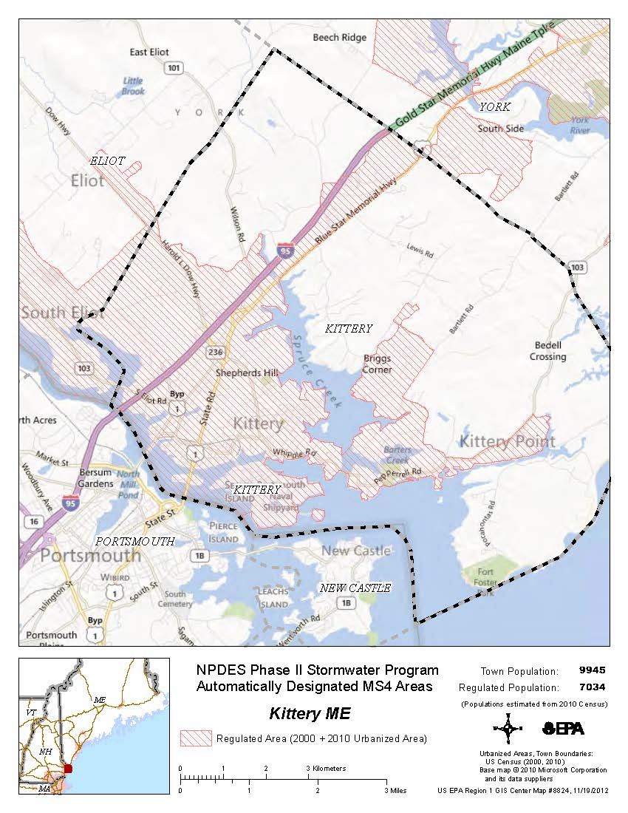

APPENDIX B
NOTICE OF INTENT and PERMITTEE SPECIFIC DEP ORDER

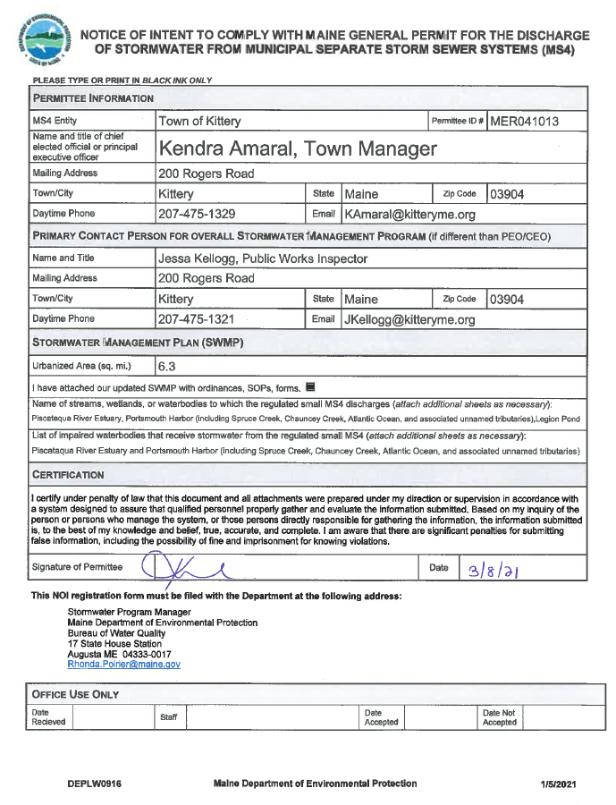

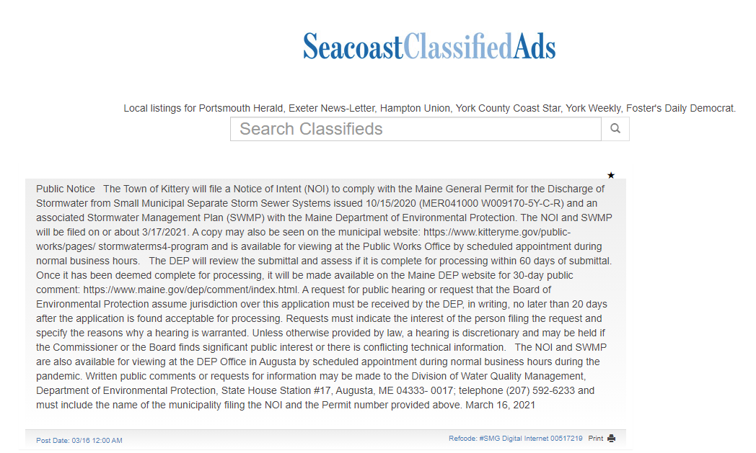
Filed in the Portsmouth Herald 3/16/2021

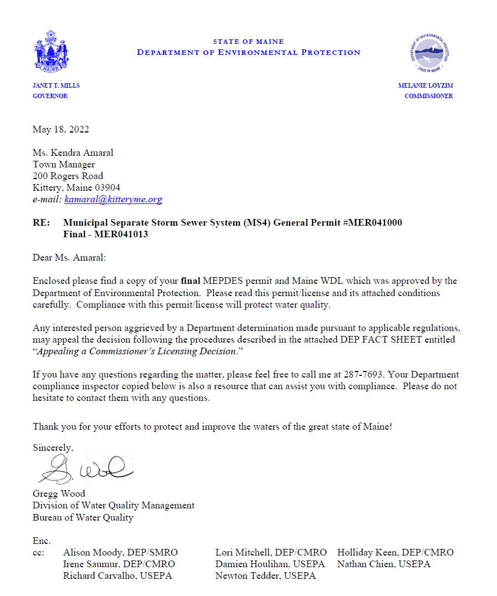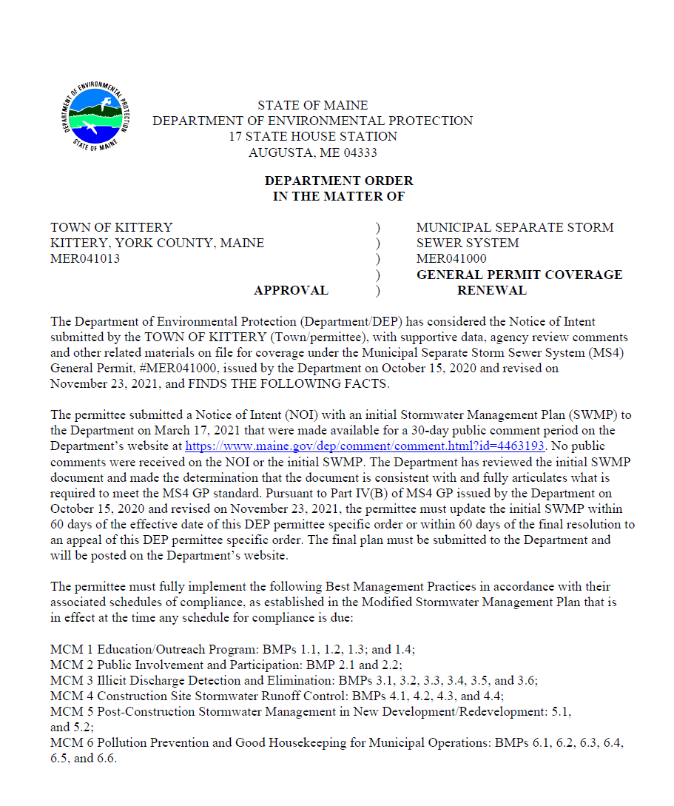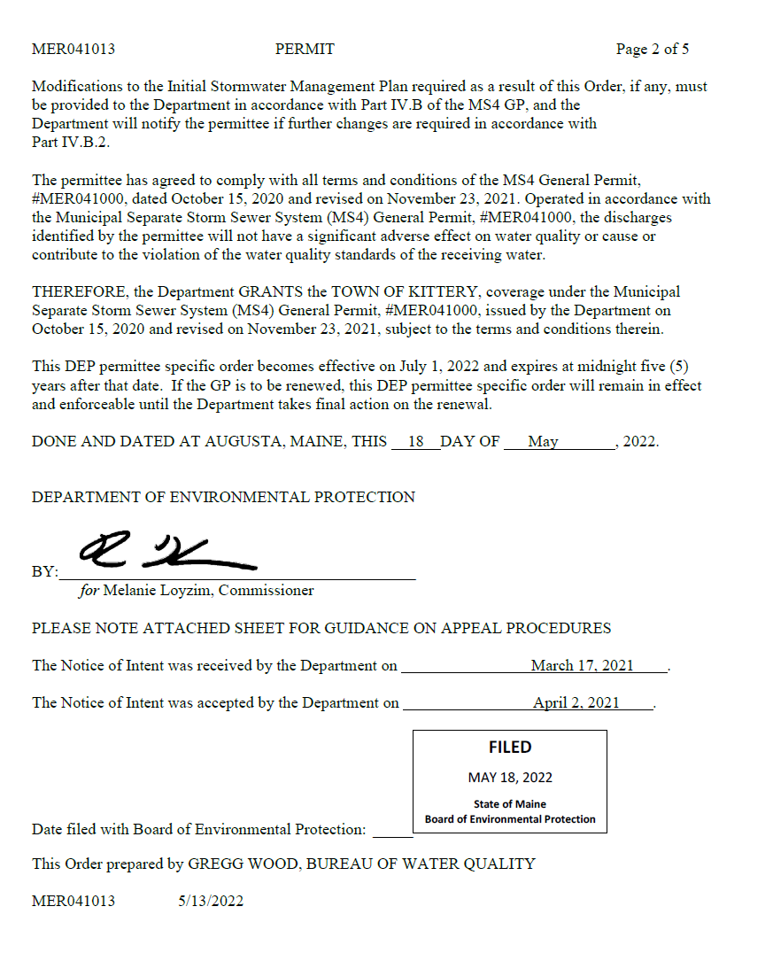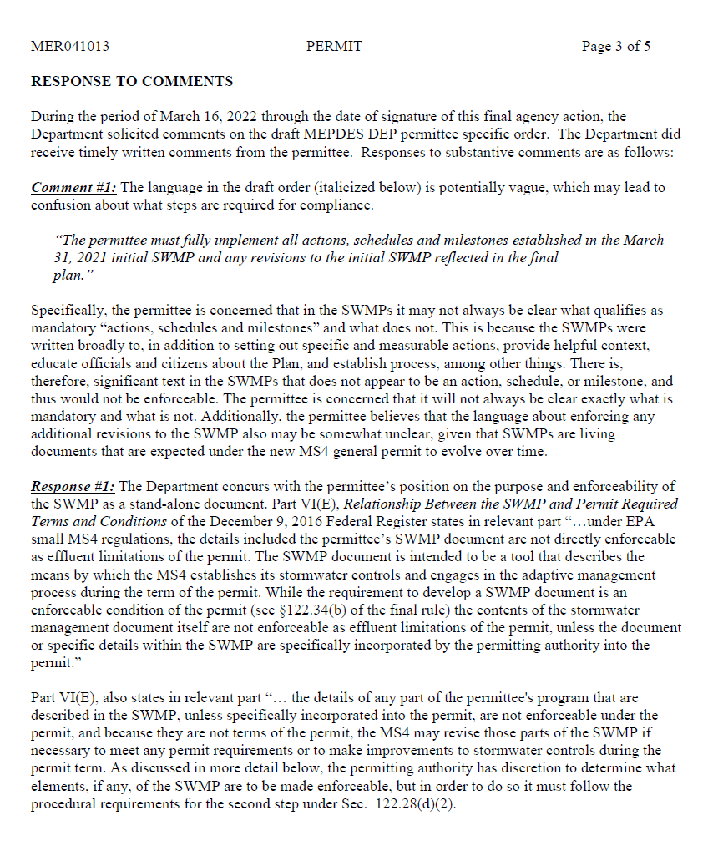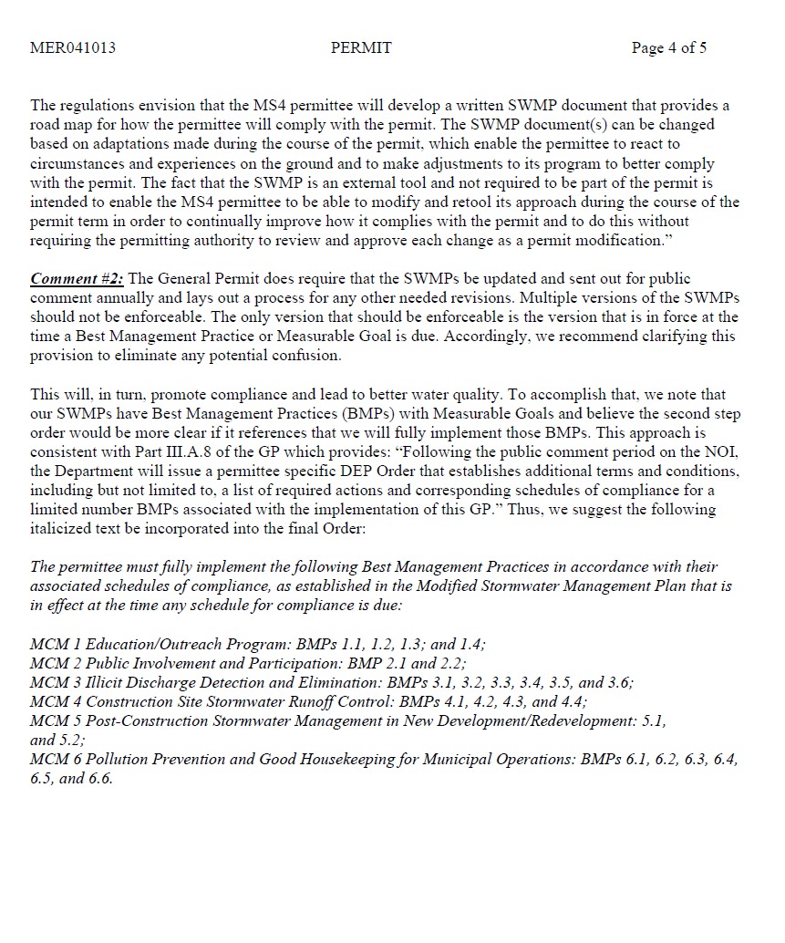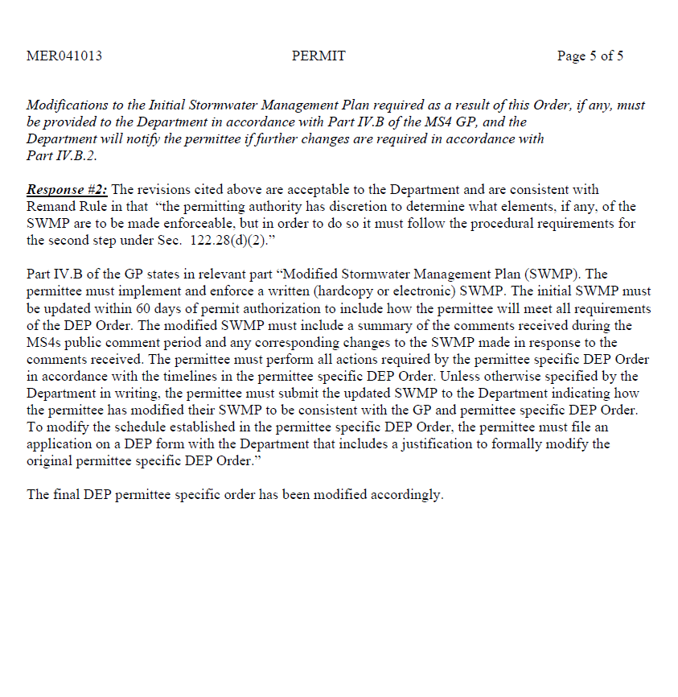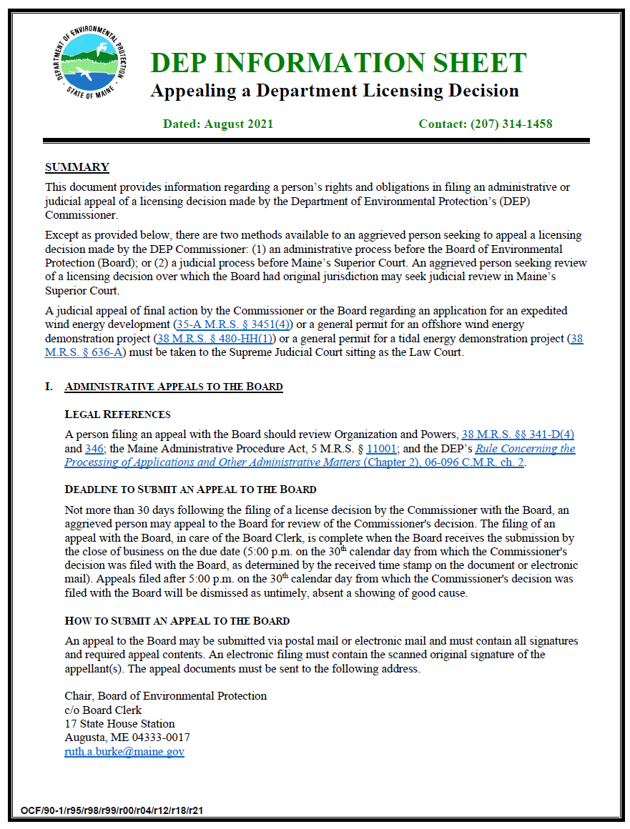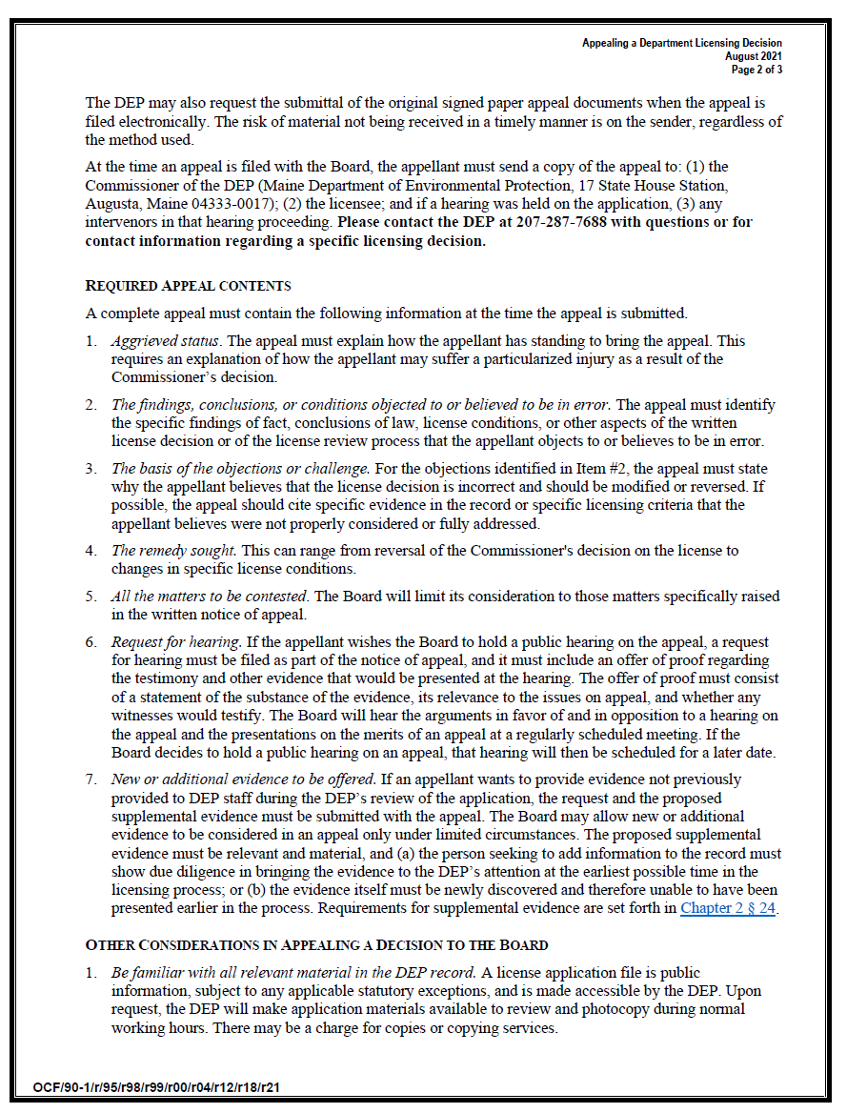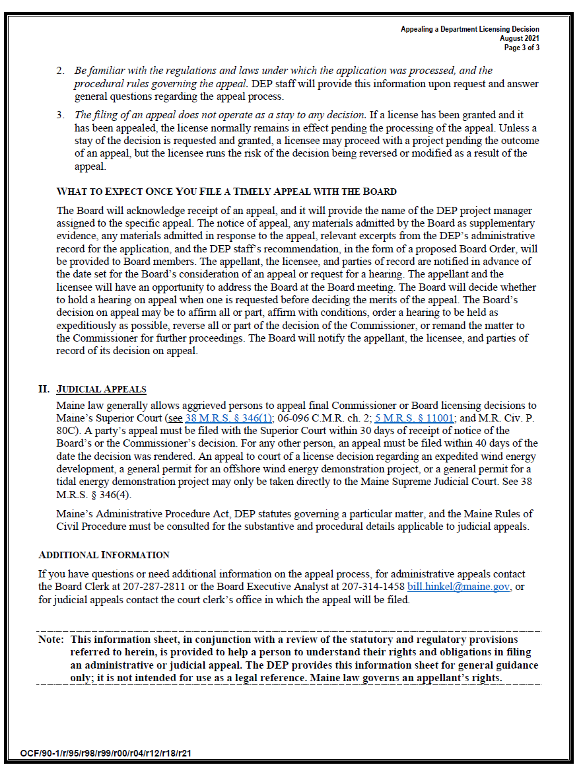

APPENDIX C
SUMMARY OF PUBLIC COMMENTS RECEIVED

The public comment period for the initial SWMP (offered by Maine DEP) lasted from 4/13/2021 to 5/12/2021. No public comments were received.

************************************************************

Municipal applications for permit coverage under the 2022 General Permit for the Discharge of Stormwater from Small Municipal Separate Storm Sewer Systems (MS4).
04/12/2021 12:08 PM EDT

The Department is posting for public comment Municipal applications, including Notice of Intent to Comply (NOI) and Stormwater Management Plans (SWMP), for municipalities seeking coverage under the 2022 General Permit for the Discharge of Stormwater from Small Municipal Separate Storm Sewer Systems (MS4).
Submit written comments to Rhonda Poirier rhonda.poirier@maine.gov by 5:00 p.m. May 12, 2021.
Municipal NOI and SWMP files for comment.
A request for public hearing must be received by the DEP, in writing, no later than 20 days after the application is found acceptable for processing. Requests must indicate the interest of the person filing the request and specify the reasons why a hearing is warranted. Unless otherwise provided by law, a hearing is discretionary and may be held if the Commissioner or the Board finds significant public interest or there is conflicting technical information.
****************************************************

The permittee specific DEP Orders were issued for public comment in November 2021 on the Maine DEP website. Comments received were as follows (attachments not included, but available from DEP):

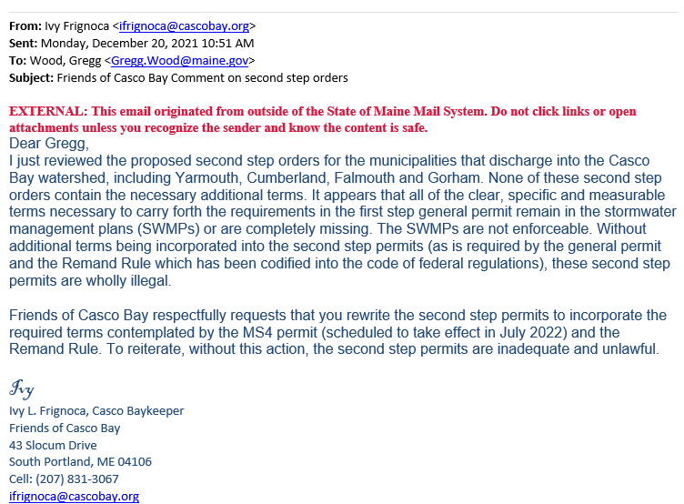
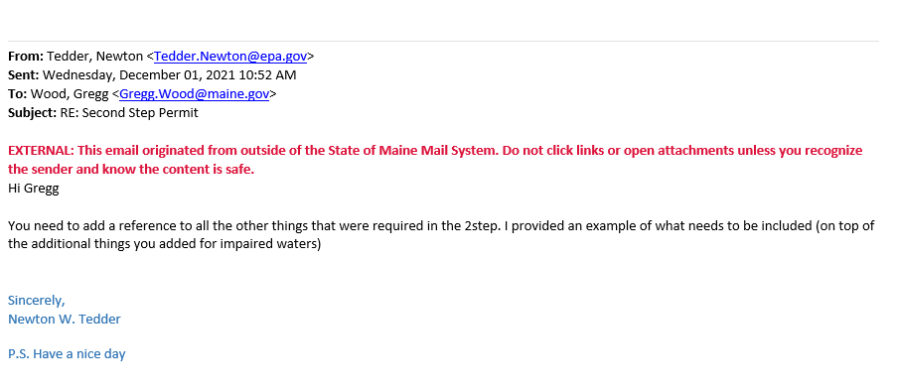
Based on comments received from the EPA and Friends of Casco Bay, the DEP issued the permittee specific DEP Orders again on 3/16/2022 to address their comments. The comments received and how they were addressed are attached to the Final Department Order contained in Appendix B of this SWMP.

APPENDIX D
EDUCATION AND OUTREACH TOOLS FOR AWARENESS

Appendix D: Education & Outreach Tools, Levels of Effort, and Effectiveness Benchmarks

Table 1 provides a list of tools with their corresponding minimum level of effort and effectiveness benchmark that will be selected from each year to implement BMP 1.1 for the Statewide Awareness Program.
Table 1. Tools for Measurable Goal 1.1a. (People 25 to 34 in the SMSWG region)

Outreach Tool | Minimum Level of Effort | Effectiveness Benchmark
SMSWG Website Content | Semiannual updates to website content | Number of visitors to website
Social Media Post (each platform counts as separate tool) | 12 posts | Amount of post engagement (e.g., reactions, comments, shares, etc.)
Social Media Ad (each platform counts as separate tool) | Ad(s) run 90 days (multiple ads may be run for shorter durations to total 90 days) | Amount of ad engagement (e.g., reactions, comments, shares, link clicks, etc.)  Number of people reached with ad
Social Media Video (each platform counts as separate tool) | 3 videos | Amount of video engagement (e.g., views, reactions, comments, shares, etc.)
Online ad | Ad(s) run 90 days (multiple ads may be run for shorter durations to total 90 days) | Number of people reached with ad  Amount of ad engagement (e.g., link clicks)
Outreach Tabling | 3 events | Number of interactions
Outreach partnership with local organization | 3 content shares by partner organization | Number of people reached
Other DEP-approved tools | Minimum level of effort will be determined based on the tool | Effectiveness benchmark will be determined based on the tool

APPENDIX E
IDDE PLAN AND QAPP

APPENDIX F
CONSTRUCTION INSPECTION FORMS

Construction Inspection Form for Sediment and Erosion Control
Site Name:  Map/Lot: | Date of Inspection:
Inspector: | Inspection Time: AM/PM
Pictures Taken: | Weather:
Type of Inspection:
Initial / Return / Winter Stabilization / Final Stabilization / Complaint / Other ____________

Inspection Parameters |  | Comments/Follow up Date
Description and estimate of construction area that is disturbed:
Does contractor have Erosion and Sediment Control Plan, drawings, and inspection log on site? | Yes / No / NA
Is the contractor or a third-party inspector conducting inspections after rain events and weekly as required by the Erosion and Sediment Control Plan for the site? | Yes / No / NA
Is the construction entrance clean with no track out of sediment? | Yes / No
Is waste properly managed (concrete washout disposed of properly, no liquids in waste container, waste containers closed)? | Yes / No
Are there any petroleum or hazardous materials on site, and if so, are there spill controls in place? | Yes / No
Review the site plan for sediment and erosion control requirements. Select “Pass” if structures are properly installed and functioning as required. Select “Fail” if contractor needs to make corrections or repairs and describe briefly repairs needed.
Select “N/A” for “Not Applicable” if they do not apply at the site.
Catch Basin Protection | Pass / Fail / NA
Silt Fence /Hay bales | Pass / Fail / NA
Erosion Control Berm or Sock | Pass / Fail / NA
Dust Control | Pass / Fail / NA
Dewatering | Pass / Fail / NA
Other:____________________________ | Pass / Fail / NA
Any Areas of Repeated Non-compliance that require MDEP Notification? | Yes / No
Any other comments?

Indicators related to the execution of the outreach program.
Indicators related to the achievement of the goals or objectives of the program.

