Illicit Discharge Detection and Elimination Program

For the

Town of Kittery, Maine
For the

General Permit for Stormwater Discharges from Municipal Separate Storm Sewer Systems

Last Updated August 2023

12 Farms Edge Road
Cape Elizabeth, Maine 04107
Ph: 207-415-5830

Table of Contents
1.0 INTRODUCTION 1
1.1 IDDE Responsibilities in the Town 1
1.2 Amendments and updates to the IDDE Program 2
1.3 Typical Illicit Discharges 3
1.4 Overview of IDDE Program Components 4
2.0 STORMWATER INFRASTRUCTURE MAP 7
2.1 Infrastructure Naming Protocols 7
2.2 Procedures to Update Map of Infrastructure 8
3.0 AUTHORITY TO PROHIBIT ILLICIT DISCHARGES 8
4.0 IDENTIFICATION OF PRIORITY AREAS 11
5.0 PROCEDURES TO LOCATE POTENTIAL ILLICIT DISCHARGES 13
5.1 Catch Basin Cleaning Inspections 13
5.2 Citizen Reports of Illicit Discharges 14
5.3 Dry Weather Outfall Inspections 14
5.4 Outfall Sampling and Analysis 15
5.5 Ditch Inspections 16
5.6 Septic System Inspections 16
5.7 Interconnections and Coordination with Other Entities 16
6.0 PROCEDURES TO INVESTIGATE 17
7.0 PROCEDURES TO REMOVE ILLICIT DISCHARGES 18
8.0 PROCEDURES TO DOCUMENT ILLICIT DISCHARGES 19
9.0 NOTIFICATIONS DURING WORKING AND NON-WORKING HOURS 19
10.0 RECORDS RETENTION 20
11.0 REFERENCES 20

List of Attachments
- KITTERY WATERSHED MAP
- INSPECTION FIELDS AND DOMAINS IN GIS
- QUALITY ASSURANCE PROJECT PLAN
- COORDINATION LETTERS WITH INTERCONNECTED MS4S

Maine DEP defines an illicit discharge as any discharge to an MS4 that is not composed entirely of storm water, except that the following are not considered illicit discharges:
- Discharges authorized under a Maine DEP permit (38 M.R.S §413. )
- Uncontaminated groundwater,
- Water from a natural resource (such as a wetland), or
- an allowable non-storm water discharge.
See Section 3.0 of this Plan for a list of the allowed non-storm water discharges.

INTRODUCTION

The Town of Kittery is subject to the requirements of the Maine Department of Environmental Protection (Maine DEP) General Permit for Stormwater Discharges from Municipal Separate Storm Sewer Systems (hereafter referred to as the MS4 General Permit).

The MS4 General Permit requires permittees to address six Minimum Control Measures throughout the Town’s Urbanized Area:

- Education/ Outreach on Stormwater Impacts
- Public Involvement and Participation
- Illicit Discharge Detection and Elimination (IDDE)
- Construction Site Stormwater Runoff Control
- Post-Construction Stormwater Management in New Development and Redevelopment
- Pollution Prevention/Good Housekeeping for Municipal Operations

This document describes the IDDE Program for the Town of Kittery, Maine. The IDDE Program described in this document fulfills the Minimum Control Measure 3 IDDE requirements specified in Part IV.C.3.b of the 2022 MS4 General Permit.

IDDE Responsibilities in the Town

The Town’s Public Works Director is responsible for overall permit compliance, and for implementation of this IDDE Plan. The following other Town personnel support implementation of this Plan:
Public Works Inspector: Responsible for outfall inspections, oversight of catch basin inspections and ditch inspections, illicit discharge investigations, and facilitates any required ordinance changes related to non-stormwater discharges through Planning Board.
Public Works staff: conduct catch basin and opportunistic ditch inspections assist Public Works Inspector in conducting illicit discharge investigations.
Code Enforcement Officers: assist Public Works Inspector in conducting illicit discharge investigations.

Amendments and updates to the IDDE Program

The MS4 General Permits are designed to provide coverage for five-year periods. The first MS4 General Permit applicable to the Town of Kittery became effective in 2003 and expired in 2008. Subsequent General Permits were issued in 2008 and 2013, providing the Town with continuous coverage for their stormwater discharges. The 2013 MS4 General Permit was administratively continued until a new permit becomes effective 7/1/2022.
This IDDE Program has been developed to meet the requirements of the 2013 and 2022 General Permits. This Plan will be updated if any of the following occur:

- requirements change because a new permit is issued,
- the Town of Kittery identifies that the Program is not effective;
- municipal operations change which need to be reflected in this Program.

The Public Works Inspector will either modify this IDDE program or engage a third party to update the document.

The following table briefly summarizes the origin and amendments to this document.
Date of Document | Description of changes
September 2014 | Original development of IDDE Plan
March 2021 | Updated content to reflect 2022 MS4 General Permit requirements.
June 2022 | Updated content to removal of optional and other items not required by MS4 General Permit and to update contact information

Typical Illicit Discharges

The Center for Watershed Protection (CWP) developed a comprehensive IDDE Manual in 2004, updated in 2011, which classifies illicit discharges into three categories related to frequency of discharge. This categorization allows communities to develop a comprehensive IDDE program that will address all kinds of illicit discharges. The three categories of illicit discharges identified in the CWP manual are described below:

- Transitory illicit discharges are typically one-time events resulting from spills, breaks, dumping, or accidents. Examples of transitory illicit discharges include:
  - paint equipment rinse water
  - carpet cleaning water
  - sediment from construction sites
  - wash water from vehicles other than individual residential car washing by an owner
  - oil or gasoline spill from a vehicle crash or other source
  - yard waste
  - litter or pet waste
Transitory illicit discharges are often reported to an authority through a citizen complaint line or following observation by a municipal employee during regular duties. Because they are not recurring, they are the most difficult to investigate, trace, and remove. The best method to reduce transitory discharges is through general public education, education of municipal personnel to minimize spills and accidents, tracking of discharge locations (to identify potential patterns associated with spills), and enforcement of an illicit discharge ordinance.
An outfall is the last accessible point before storm water discharges to a water body. Some things that are NOT outfalls include: driveway culverts that connect ditch segments, culverts that convey water bodies under roadways, and pipes that discharge to other storm water infrastructure elements.
- Intermittent illicit discharges occur occasionally over a period of time (several hours per day, or a few days per year). Intermittent discharges can result from legal connections to the storm drain system, such as a legal sump pump connection that is illegally discharging washing machine water, a single home sanitary connection, or from illegal connections such as floor drains from industrial or commercial operations. Intermittent discharges can also result from activities such as excessive irrigation or wash down water from exterior areas. The 2022 General Permit requires that MS4s consider illicit discharges that might result from dumping. One example of this would be trash or litter dumped in/near stormwater structures might leak leachate into the system intermittently. Because intermittent discharges are longer lasting than transient, they are more likely to be discovered during an opportunistic or regularly scheduled inspection. They are less difficult to trace and remove than transitory discharges but can still present significant challenges. These discharges can have large or small impacts on water bodies depending on pollutant content.
An outfall is the last accessible point before storm water discharges to a water body. Some things that are NOT outfalls include: driveway culverts that connect ditch segments, culverts that convey water bodies under roadways, and pipes that discharge to other storm water infrastructure elements.
- Continuous illicit discharges are typically the result of a direct connection from a sanitary sewer, overflow from a malfunctioning septic system, or inflow from a nearby subsurface sanitary sewer that is malfunctioning. Continuous illicit discharges are usually easiest to trace and can have the greatest pollutant load but are typically the most costly and time consuming to correct because they likely involve construction and alteration of subsurface connections. (CWP and Robert Pitt 2004)

Overview of IDDE Program Components

The MS4 General Permit requires an IDDE program be developed and implemented which contains six components. An overview of each component is provided in this subsection, and the remaining sections of this document describe how the Town of Kittery is implementing each component.

- Development of a watershed-based map: The Town is required to develop a map of the storm sewer system infrastructure including watersheds, catch basins, connecting surface and subsurface piping, outfalls, and ditches. The catch basins and outfalls must have unique identifiers. The following information must be included in the map system for outfalls: the type of outfall (a connected pipe, a culvert, or a ditch), the material, its size, the name and location of the nearest named water body to which it discharges. Section 2.0 of this document describes the Town’s watershed-based map.

- Authority to Prohibit Illicit Discharges: To the extent allowable under state or local law, the Town must effectively prohibit, through an ordinance or other regulatory mechanism, non-storm water discharges into the system and implement appropriate enforcement procedures and actions. Section 3.0 of this document describes how the Town’s Non-Stormwater Discharge Ordinance is implemented.

- Identification of High Priority Areas for Inspections: Prior MS4 General Permits required that the Town identify priority areas that need to be protected from illicit discharges. The 2022 MS4 General Permit does not have this requirement, but it does require that the Town have “Procedures for prioritizing watersheds”. The Town uses the prioritization for illicit discharge inspections as described in Section 4.0 of this document, including a discussion of the basis for determining the high priority areas.

- Procedures to Locate Illicit Discharges: The Town must develop procedures for locating illicit discharges (i.e., visual screening of outfalls for dry weather discharges, dye or smoke testing). The Town addresses this by conducting dry weather outfall inspections and assessing catch basins for evidence of pollutants, and by conducting opportunistic ditch inspections. The 2022 MS4 General Permit also requires monitoring be conducted on outfalls that are flowing during dry weather. Section 5.0 of this document describes the Town’s inspection program.

- Procedures to Investigate and Remove Illicit Discharges: The Town must develop procedures for locating the source of the discharge and procedures for the removal of the source. Sections 6.0 and 7.0 of this document describe how the Town investigates and removes illicit discharges.

- Procedures to Document Illicit Discharges: The Town must develop procedures for documenting actions and evaluating impacts on the storm sewer system subsequent to the removal. Section 8.0 describes how the Town tracks illicit discharges.

- Emergency Notifications: Section 9.0 describes procedures for emergency notifications of illicit discharges outside of the hours when Public Works is open.

Section 10.0 of this document describes the record retention requirements of the MS4 General Permit and Section 11.0 of this document provides references.

STORMWATER INFRASTRUCTURE MAP

Kittery’s stormwater structures were initially surveyed using Global Positioning System (GPS) data collection and field observations in 2005 and initial maps were created using a Geographic Information System (GIS) program. For a while, the maps were updated as pdf snapshots of a GIS map book, but in 2014 the mapping system was moved to be completely electronically. As of approximately 2014, the Town gained the ability to update the maps using ArcGIS Online. The URL for the data accessible by staff is: http:/kittery.maps.argcis.com

The Town provides read-only public access to the map of the storm drain system at Kittery, ME (axisgis.com). Inspection information, size, ownership and materials of construction is available to the public. Annually, the data is extracted from the ArcGIS On-line account and imported to the public facing site, so although the staff have access to data with real-time changes, the publicly available data is only updated annually. All data uses the Maine State Plane Coordinate System West Fipszone 1802 ADSzone; 4101 UTM Zone 19).

The Town’s Public Works Inspector has overall responsibility for data integrity, and GIS licensing. The following sections describe the Town’s naming protocol for the infrastructure, specifics on how updates to the system are completed, and information on how the Town coordinates with other MS4s that have interconnected stormwater infrastructure.

Infrastructure Naming Protocols
The Town’s GIS identifies infrastructure with unique numeric IDs. Outfalls are numbered between 1 and 999. Catch basins and drain manholes are numbered between 1 and 9,999. Ditches are also provided with numeric ids that range from 1 to 999. When referring to structures for maintenance or illicit discharge purposes, town personnel typically refer to the type and number of the structure. For example, catch basins are referred to as “catch basin 4445” or “CB-4445” and outfalls are referred to as “Stormwater Outfall 2” or “OF-2” or “SWO-2”.

Procedures to Update Map of Infrastructure
The Town makes changes to the storm drain infrastructure in several ways. The following describes the scenarios under which the infrastructure might change, requiring a mapping update:

- Generally, the Public Works Department constructs minor changes to the system based on immediate or planned need without formal design drawings. When these types of changes are made, the Town staff can update the online GIS directly using an iPad or can request that a third-party contractor update the online GIS. New or replaced outfalls and structures are given a new number and the material of construction, size, and other pertinent information is recorded.

- More significant changes are typically constructed after preparation of formal design drawings, whereupon either the Public Works Department or a private contractor constructs the changes. Where a private contractor constructs the changes, the Public Works Department conducts a formal site review of the as-built conditions. The Public Works Department would provide the as-built drawings to the third-party contractor for incorporation into the GIS.

The GIS data is not survey quality, but it does provide crews with real-time information on infrastructure connectivity and locations.

AUTHORITY TO PROHIBIT ILLICIT DISCHARGES

The Town of Kittery authority to prohibit illicit discharges is a component of the Land Use and Development Code (Title 16 Part 2 16.9.7 Article VII Non-Stormwater Discharge Ordinance). The ordinance was modified to be Town-specific from a model ordinance created by the Maine Municipal Association for other Towns that are regulated by the MS4 General Permit. Though the MS4 General Permit is only applicable to the Urbanized Area of Town, the Town implements the Non-Stormwater Discharge Ordinance in all areas of Town.

The Ordinance allows the following non-stormwater discharges to the storm drain system as long as the discharges do not cause or contribute a violation of the state’s water quality criteria:

- landscape irrigation;
- diverted stream flows;
- rising ground waters;
- uncontaminated ground water infiltration (as defined at 40 CFR 35.2005(20);
- uncontaminated pumped ground water;
- uncontaminated flows from foundation drains;
- air conditioning and compressor condensate;
- irrigation water;
- flows from uncontaminated springs;
- uncontaminated water from crawl space pumps;
- uncontaminated flows from footing drains;
- lawn watering runoff;
- flows from riparian habitats and wetlands;
- residual street wash water (where spills/leaks of toxic or hazardous materials have not occurred, unless all spilled material has been removed and detergents are not used);
- hydrant flushing and firefighting activity runoff;
- water line flushing and discharges from potable water sources;
- individual residential car washing; dechlorinated swimming pool discharges.

The Public Works Inspector, who is a Code Enforcement Officer, enforces the ordinance.

It should be noted that discharges associated with dye testing are also allowed with verbal notice to a Code Enforcement Officer.

In addition, discharges of hydrant and water line flushing are required to be dechlorinated if they are to be discharged to a portion of the MS4 system which discharges to a small stream. In accordance with the Maine DEP 11/18/2016 Issue Profile for Drinking Water System Discharges to Regulated Small MS4s, the Kittery Water District either aerates or dechlorinates during flushing to meet Total Residual Chlorine (TRC) acute water quality criteria as follows:
- Fresh water 19 ug/L (adjusted to 50 ug/L, per the Maine DEP as the reporting limit for available reliable and consistent test methods)
- Marine water 13 ug/L (adjusted to 50 ug/L, per the Maine DEP as the reporting limit for available reliable and consistent test methods)

The Kittery Water District flushes the system annually, typically in the spring, and provides a report to the Public Works Inspector describing water dechlorination methods in use and testing results for any flushing conducted.

IDENTIFICATION OF PRIORITY AREAS

The Town of Kittery recognizes the Natural Resources Conservation Service (NRCS) national hydrologic unit code (HUC) numbering system. The NRCS national HUC system identifies watersheds down to the sub-watershed level, which have 12-digit HUC numbers.
The Town has further defined a drainage area (14-digit HUC area) that they refer to as the Spruce Creek Watershed. The relationship between these areas is shown in Table 1, and a graphic of the areas is shown in Appendix A.

Table 1
Watersheds, Sub-watersheds, and Drainage Areas
Town of Kittery, Maine
Watershed  (10-digit HUC) | Sub-watershed  (12-digit HUC) | Drainage Area  (14-digit HUC) | Notes
Frontal Drainages of Southern York County (0106000311) | York River (0106000311-03) | None | Only a very small portion of the Town’s Urbanized Area discharges to this area.
 | Braveboat Harbor (0106000311-04) | None | Only a very small portion of the Town’s Urbanized Area discharges to this area.
Hampton River-Frontal Atlantic Ocean (0106000310) | Portsmouth Harbor (0106000310-01) | Spruce Creek | Approximately 80% of the Town’s Urbanized Area Discharges to this area.

Approximately 8o% of the Town’s Urbanized Area is contained within the watershed called, Hampton River Frontal Atlantic Ocean (HUC 0106000310). The remaining portions of the Urbanized Area are contained in the watershed called, Frontal Drainages of Southern York County (HUC 0106000311).

The town’s priority watershed is the Hampton River Frontal Atlantic Ocean Watershed.
Because the only Sub watershed in the priority watershed is Portsmouth Harbor, Portsmouth Harbor is the Town’s Priority Sub watershed.

Spruce Creek is an area that has received grassroots support for water quality protection and restoration. Spruce Creek is in the Portsmouth Harbor Sub watershed.

The Town does not prioritize inspections or illicit discharge investigations because the vast majority of the infrastructure is in the priority watershed/subwatershed.

PROCEDURES TO LOCATE POTENTIAL ILLICIT DISCHARGES

The Town of Kittery uses the following methods to locate illicit discharges:

1. Observations during catch basin cleaning
2. Citizen reports of illicit discharge issues
3. Dry weather outfall inspections
4. Outfall Sampling and Analysis
5. Opportunistic Ditch inspections
6. Other opportunistic Inspections

Each of these methods is described in the following subsections. The inspections are conducted using an iPad and stored with the GIS spatial data. Attachment B contains a table showing the fields that are completed during outfall, ditch and catch basin inspections using the GIS.

Catch Basin Cleaning Inspections

The 2022 MS4 General Permit requires catch basin inspection every other year. During the inspection process, the employee is also inspecting to assess if any oil, litter, sewage, pet waste, cigarette butts or other evidence of illicit discharges is present. If the employee sees any evidence of illicit discharges, the evidence is documented using an electronic data collection device such as an iPad in the ArcGIS on-line files. The Public Works Department has direct access to the data on the iPad as the inspections are being completed.

The Town’s third-party contractor downloads the inspection information and provides the Town with a summary spreadsheet after the inspections are completed. This spreadsheet provides the Public Works Inspector with information on illicit discharges that need follow up as well as maintenance.

Citizen Reports of Illicit Discharges

Citizen reports of illicit discharge issues are typically routed to and investigated by the Public Works Inspector or a Code Enforcement Officer. The report is investigated typically within one week. The reports are documented in an excel spreadsheet as described in Section 8 of this IDDE Plan.

Dry Weather Outfall Inspections

The Town will inspect outfalls at least once per permit cycle as required by the MS4 General Permit. Inspections are completed in accordance with the following:

- Inspections will be performed during periods of dry weather whenever possible.
- Inspections will be performed where field inspections may be performed in a safe and efficient manner;
- Inspections will be performed during periods of no or minimal snow cover and prior to the growth of vegetation (or after leaves have fallen) such that outfalls may be easily spotted;
- Observations will include the follow at a minimum: observations of sheen, discoloration, foaming, evidence of sanitary sewage, excessive algal growth and similar visual indicators, and detection of odor;
- Photographs may be taken at the time of inspection for either maintenance or illicit discharge documentation.
- MS4 outfalls will be inspected where the Town has safe and legal access to the structure to be inspected.
- When maintenance or potential illicit discharge issues are identified, the Public Works Inspector will be informed so that the Department may prioritize the work with other required work for the Town.

Town staff with ArcGIS Online user IDs are able to view the data online for the current permit year. Copies of the inspections conducted for the current permit cycle are downloaded from the online system and summarized for the annual report.

Outfall Sampling and Analysis

Outfall sampling and analysis is required under the 2022 MS4 General Permit when an outfall is observed to be flowing during dry weather conditions whether or not it has exhibited evidence of an illicit discharge.

Outfalls and/or other structures may also be sampled if other evidence of illicit discharges is observed during inspection. The Public Works Inspector may solicit the assistance of a third-party contractor to collect a sample for field screening depending on the conditions encountered.

A Quality Assurance Project Plan (QAPP) has been developed to provide sampling personnel the information that will assist them in collecting samples and using field equipment, test kits and obtaining analyses. The QAPP describes the sampling procedures that should be used as well as the analytical methods and field equipment that are appropriate for use in investigating potential illicit discharges and flowing outfalls. The QAPP also provides guidance on interpretation of the results obtained so that investigators can make informed decisions about whether to continue investigating a potential source, or whether the results indicate a flowing outfall might be from a natural source. The QAPP is provided in Attachment C to this IDDE Plan.

Wet weather sampling is not required by the MS4 General Permit at this time, but the Public Works Inspector may choose to conduct wet weather sampling if they suspect a discharge occurs only during wet weather (such as may be the case for failed septic systems).

Ditch Inspections
The 2022 MS4 General Permit does not require ditch inspections be completed. Ditch inspections were completed by the Public Works Department on all ditches during the previous permit cycle. The ditch inspections were previously completed using the GIS.

Moving forward, the Town Public Works Staff will generally inspect ditches for potential illicit discharges whenever maintenance work on ditches is being completed. The Town follows these guidelines in conducting inspections:

- Field inspection will be performed during periods of dry weather when possible.
- Inspections are documented in the GIS.
- Inspections will be performed during periods low flow where field inspections may be performed in a safe and efficient manner;
- Inspections will be performed during periods of no snow cover and prior to the growth of ditch vegetation such that potential outfalls may be easily spotted;
- Evidence of potential illicit discharges will be summarized in the IDDE Tracking Sheet (See section 8.0).
- If maintenance issues are identified, the Public Works Inspector will be informed so that he may prioritize the work with other required work for the Town.

Septic System Inspections
During the previous permit cycle, the Town conducted an assessment and drive by inspections of septic systems in the Urbanized Area. None of the systems were observed to have evidence of leakage or failure. Because this Plan did not yield useful information on septic system failures, it is no longer being conducted.

Interconnections and Coordination with Other Entities
The Town’s MS4 area borders the towns of Eliot and York, Maine, which are also regulated by the MS4 General Permit. Some of the roadways in Town (I 95 and the Sarah Mildred Long Bridge) are maintained by the Maine Department of Transportation (DOT) and are therefore not part of the Town’s MS4 system. The roads in the Town’s Urbanized Area that are DOT‐maintained fall under the Maine DOT’s MS4 General Permit. The Town’s maps are color coded to show which infrastructure is Town vs. Maine DOT. There are also some outfalls shown where Town infrastructure discharges to either the Maine DOT, or to another Town or private entity (such as a railroad or school).

Because of these MS4 interconnections, it may be necessary to conduct cooperative investigations with other MS4s or to inform them of issues associated with the Town’s infrastructure.

The Town has notified its interconnected MS4s of the interconnections, and has provided notification of who to contact in the event of an emergency as documented in Attachment D.

PROCEDURES TO INVESTIGATE

Investigations of illicit discharge issues are conducted by the Public Works Inspector with assistance from the Public Works Department or a third-party contractor when necessary. The Town relies on visual observations of the location where the illicit discharge was reported as a first step in identifying the source of the illicit discharge. If the evidence of the illicit discharge is still present in the initial structure or location where it was reported, the Town uses their knowledge of the infrastructure routing to systematically inspect other structures upstream of the initial location until either the evidence of the illicit discharge is no longer present, or until they locate a potential source of the illicit discharge.

For example, if evidence of gray water were observed during catch basin cleaning of a separated storm drain system, the Town would inspect drain manholes and/or catch basins upstream of the initial observation until they could isolate one or more locations from which the gray water was likely emanating.

In the event visual observations of the structures cannot identify the source of an illicit discharge, the Town may employ televising, systematic dye testing, or smoke testing to identify the source.

PROCEDURES TO REMOVE ILLICIT DISCHARGES

Once the potential source of the illicit discharge is identified, the Public Works Inspector would identify and contact the responsible party in order to initiate removal or discontinuation of the illicit discharge.

If the illicit discharge is caused by a private entity, the Public Works Inspector may invoke the authority granted him/her under the Non-Storm Water Discharge Ordinance (See section 3.0 of this IDDE Plan). The Public Works Inspector typically provides initial verbal or email notice to any responsible party, then follows up with a Notice of Violation. The Notice of Violation specifies the illicit discharge be removed within 60 days of its source identification but allows that if removal within 60 days is not possible, the responsible party must work with the Public Works Inspector to establish a schedule to remove the illicit discharge as expeditiously as possible.

If the illicit discharge is caused by the Town, the Public Works Inspector would contact the department most responsible and work with them to remove or discontinue the illicit discharge within 60 calendar days of identification of the source or would develop a schedule to expedite elimination.

PROCEDURES TO DOCUMENT ILLICIT DISCHARGES

The Town will track the progress of investigating and removing illicit discharges using an IDDE Tracking Sheet. Each year, the town is required to complete an annual report summarizing the activities completed under the MS4 Program. The Public Works Inspector will print or retain an electronic copy of the IDDE Tracking Sheet for the year as back-up documentation of investigative and removal work completed.

NOTIFICATIONS DURING WORKING AND NON-WORKING HOURS

The following describes the notifications completed during working and non-working hours to ensure that those who need to know about illicit discharges are notified:

- During working hours, if an illicit discharge is detected by a public works employee (either during a routine inspection or opportunistic inspection), the employee reports the information to the Public Works Inspector. The Public Works Inspector then investigates and ensures proper follow-up.

- Typically, illicit discharges identified by the public during non-working hours are routed to the public works, police or fire department. For example, if a spill of petroleum or hazardous material were to occur, or a discovery of a sewage discharging form a pipe, the police and/or fire department would be notified and would respond to the incident using their emergency response procedures (which include proper notifications to Maine DEP if warranted). Police and Fire would contact the Public Works Inspector during working hours in the event of an illicit discharge to the separated sewer system during non-working hours. The Public Works Inspector would ensure future follow up.
- As described previously, the Public Works Inspector may need to coordinate with the Maine DOT or the Towns of York or Eliot to resolve any illicit discharges that have interconnections with those entities. Attachment D contains contact information for other MS4 coordinators, and copies of the notices that have been provided to these entities in the event of a potential illicit discharge.

RECORDS RETENTION

The Public Works Inspector will retain paper or electronic files of inspections and investigations including laboratory reports, for a minimum of three years after expiration of the MS4 General Permit Term. For the 2013 – 2022 General Permit, reports may be discarded June 30, 2025.

Generally, documentation of inspection, investigation and tracking summaries are retained electronically by the Public Works Inspector in the Annual Report Backup for whatever year the inspections or investigation was conducted. If an illicit discharge investigation takes more than one year, the Public Works Inspector ay maintain a separate paper or electronic file for that discharge until it is resolved.

REFERENCES

CWP and Robert Pitt 2004. Illicit Discharge Detection and Elimination Manual – A Guidance Manual for Program Development and Technical Assessments. October 2004 Available: http://cfpub1.epa.gov/npdes/stormwater/idde.cfm

Aquarion Engineering Services and Casco Bay Estuary Partnership. Guidelines and Standard Operating Procedures for Stormwater Phase II Communities in Maine. Available: http://www.thinkbluemaine.org/docs/index.htm

CWP and Robert Pitt 2011 Illicit Discharge Detection and Tracking Guide Available: http://www.cwp.org/2013-04-05-16-15-03/idde

USEPA New England Bacterial Source Tracking Protocol 2012. Provided by USEPA to Integrated Environmental Engineering. Available at: https://www3.epa.gov/region1/npdes/stormwater/ma/2014AppendixI.pdf
ATTACHMENT A
WATERSHED MAP

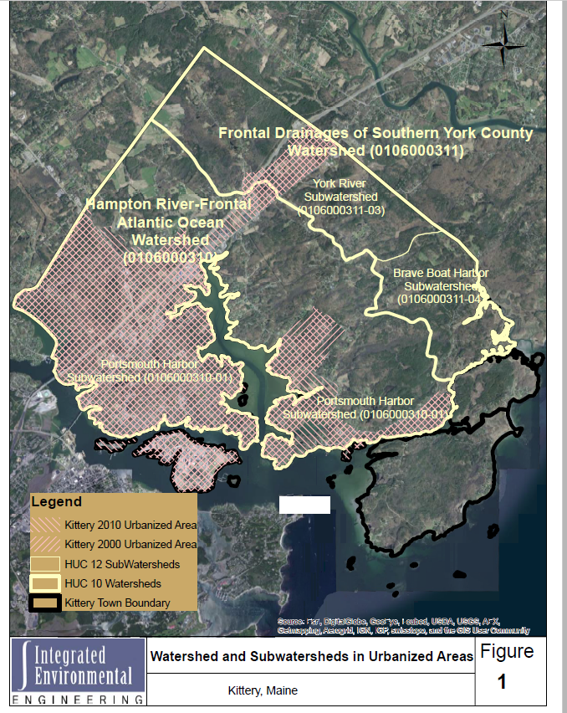
Kittery Watershed and Subwatershed

ATTACHMENT B
Inspection Fields and domains for gis

As an inspector is using the iPad in the field, they tap on the structure or element they are inspecting and record inspection data in the available fields. The Town has a basic Arc GIS license so related tables are not used. Rather each year, a third-party contractor saves a copy of the inspections in an excel table, then clears out any comments or identification of pollution or maintenance issues from the GIS and sets up the system to accept a new year of inspection records. The following is a summary of the available fields and associated drop down domain menus associated with each type of inspection. Those items in BOLD are required as part of the MS4 General Permit.

ms4 iNSPECTION | GIS fIELDS AND DOMAINS COMPLETED AS PART OF INSPECTION
Catch Basins | CatchBasin_ID – Manually entered (sequential numbers, e.g., 99)  NewInspStatus – Identifies the owner and inspection status as Needs_Insp, Complete_Dry, Complete_Wet, or Do_Not (for private infrastructure).  PYXInspDate – manually selected (X defines permit year of inspection)  NewOwner – KitteryMS4, KitteryNonMS4, MaineDOT, Private, Unknown, MTA  BASIN_COND – Excellent, Fair, Poor  NewPollution – None, Foam, ExcessAlgae, Oil_Film, Sewage_Solids, Odor, DiscoloredFlow, Multiple_Types,  TrashDmp – Yes or No  YardWasteDmp – Yes or No  CigButt – None, 1 to 5 deposits, or more than 5  PetWaste - None, 1 to 5 deposits, or more than 5  Sump – Yes or No  sumpdepth – manual entry of depth of sump if not already present in inches  NewSedSump 0_to1/2 full, 1/2full_ormore  Accessibility: Accessible, Paved_Over, Unopenable, Buried, Not_Found, Other  Follow-up – Yes or No  Location – manually entered street name or location area  StructType – CB, DMH or Other  Notes/Comments – open text field  Photos cannot be attached to the inspection but are taken if needed for IDDE documentation.
Piped Outfalls | Outfall_ID – Manually Entered (sequentially numbered e.g., 01)  NewInspStatus –Needs_Insp, Complete_Dry, Complete_Wet, or Do_Not (for private infrastructure).  PYXInspDate – manually selected (X defines permit year of inspection)  Pipe_Type – PVC, Corregated_Metal, Concrete, Steel, Transite_Asbestos_Concrete, None, Cast_Iron, Vitrified_Clay Black_Corregated_Solid, Black_Corregated_Perforated, Black_Smooth, None  PipeDiam_inches – manually entered if not already present and correct  Pipe Flow – None, Trickly, Steady, or ¼ pipe or More  Seepage Flow – None, Trickly, Steady, or ¼ pipe or More  NewPollution – None, Foam, ExcessAlgae, Oil_Film, Sewage_Solids, Multiple_Types,  Odor – None_Natural, Musty, Rancid_Sour, or Sewage_Septic  Water Clarity – Not_Applicable, Clear, Cloudy, or Opaque  Color – Brown, Tan, Gray, Other, Not-Applicable, None  Outlet_Stable: Yes or No  Sediment_Condition – Open, ¼ full, ½ full, ¾ full, or plugged  Trash_litter – Yes or No  Cig_Butts – Yes or No  Pet_Waste – None, 1 to 5 deposits, or more than 5  Yard_waste – None, 1 to 5 deposits, or more than 5  DrySample Date - Date  NeedsDrySample – Yes – Not done, Yes – Done, or Not Needed  Follow-up – Yes or No  Notes – open text field  Photos cannot be attached to the inspection but are taken if needed for IDDE documentation.  Receiving waters are also input to GIS
Ditch Outfalls | Outfall_ID – Manually Entered (sequentially numbered e.g., 01)  NewInspStatus –Needs_Insp, Complete_Dry, Complete_Wet, or Do_Not (for private infrastructure).  NewOwner – KitteryMS4, KitteryNonMS4, MaineDOT, Private, Unknown, MTA  PYXInspDate – manually selected (X defines permit year of inspection)  Flow – None, Trickly, Steady, or ¼ pipe or More  NewPollution – None, Foam, ExcessAlgae, Oil_Film, Sewage_Solids, Multiple_Types,  Odor – None_Natural, Musty, Rancid_Sour, or Sewage_Septic  FlowClarity – Not_Applicable, Clear, Cloudy, or Opaque  Color – Brown, Tan, Gray, Other, Not-Applicable, None  Outlet_Stable: Yes or No  ApproxWidth_inch  ApproxDepth_inch  Material – vegetation, riprap, paved, other  Sed_Condition – Open, ¼ full, ½ full, ¾ full, or plugged  GenCondition – Excellent, Good, Fair, Poor, or Needs Attention  Trash_litter – Yes or No  Cig_Butts – None, 1 to 5, more than 5  Pet_Waste –None, 1 to 5, more than 5  Yard_waste – Yes or No  DrySample Date - Date  NeedsDrySample Yes – Not Done, Yes – Done, or Not Needed  Follow-up – Yes or No  Notes – open text field  Photos cannot be attached to the inspection but are taken if needed for IDDE documentation.  ReceivingWaters are also input to GIS
Ditches | Ditch ID – Auto populated  InspectionType – Needs_Inspection, Wet_Inspection_Completed, Dry_Inspection_Completed, Do_Not_Inspect  InspDate2023_2027 – manually selected  Condition – Excellent, Fair or Poor  Trash/Litter Present – Yes or No  Yard Waste Present – Yes or No  Cig_Butts – None, 1 to 5, more than 5  Pet_Waste –None, 1 to 5, more than 5  Pollution – None, Foam, ExcessAlgae, Oil_Film, Sewage_Solids, DiscoloredFlow, Multiple_Types  Odor – None_Natural, Musty, Rancid_Sour, or Sewage_Septic  Standing Water – Yes or No  BaseFlow – Yes or No  Water Clarity – Not_Applicable, Clear, Cloudy, Opaque  Excess_Sediment – Yes or No  Excess Vegetation – Yes or No  Invasive_poison_Vegetation – Yes or No  Erosion/Scouring - Yes or No  WoodyVegetation – Yes or No  Notes – open text field  Follow-up – Yes or No

ATTACHMENT C
QUALITY ASSURANCE PROJECT PLAN

ATTACHMENT D
COORDINATION LETTERS WITH INTERCONNECTED MS4S

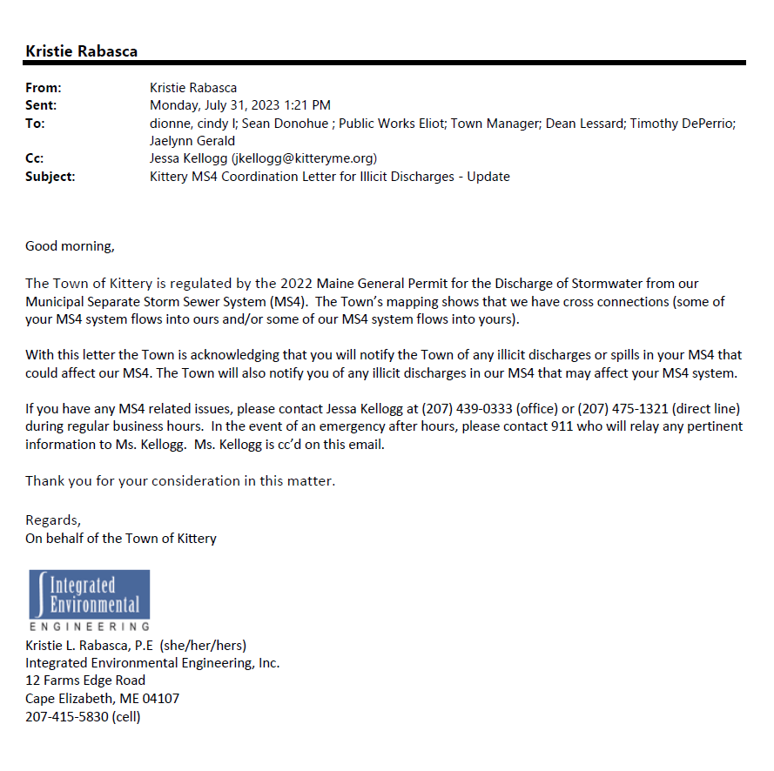

Interconnected MS4 | Date of update | Contact | Phone | E-mail
Maine DOT | 7/31/2023 | Cindi Dionne | 207-592-3489 | cindy.l.dionne@maine.gov
Town of York | 7/31/2023 | Dean Lessard, Tim DePerrio, or Jaelynn Gerald |  | dlessard@yorkmaine.org  tdeperrio@yorkmaine.org  jgerald@yorkmaine.org
Town of Eliot | 7/31/2023 | Public Works Director | 207-439-9451 | publicworks@eliotme.org
Maine Turnpike Authority | 7/31/2023 | Sean Donohue | 207-232-7130 (o)  207-232-7130 (c) | sdonohue@maineturnpike.com

